**Introduction:**

Natural disturbances, including fires, windstorms, floods, droughts, and insect outbreaks, have occurred in forests for millions of years (Lindenmayer et al. 2012). In forests of the eastern United States, wind disturbance from hurricanes, derechos (straight-line windstorms), and tornados is a dominant disturbance regime (Fischer et al. 2013). When windstorms knock down canopy trees, the increased sunlight reaching the understory and forest floor can induce environmental changes. Soil temperature extremes can increase, moisture can change depending on reduced evapotranspiration but increased summer temperature, leaf litter depth can decrease due to faster decomposition, and understory plants increase their growth rates (Greenberg and Forrest 2003, Urbanovi et al. 2014, Barber and Widick 2017). The growth of understory plants interacts with tree mortality and the creation of canopy gaps to alter microclimatic conditions (Perry et al. 2018). The fallen canopy trees cause an influx of woody debris, including both coarse and fine woody debris. Uprooted trees create tip-up mounds that alter topography of the forest floor (Perry and Herms 2019). While wind disturbance changes canopy cover and abiotic conditions, it also leaves behind many living trees, understory shrubs and herbaceous plants, seeds, root systems, soils, and surviving animals. These elements left intact after a disturbance are called biological legacies, and they influence short- and long-term changes in forest structure and function (Lindenmayer et al. 2012).

Harvesting the fallen trees after a natural disturbance is a practice called salvage-logging, and this management practice is a common response to windstorms (Lindenmayer et al. 2012). Salvage logging can help landowners recover the economic value of the fallen trees, or it may be motivated towards reducing fire risk, insect outbreak risk, or safety hazard (Perry and Herms 2019). However, there is a growing interest in managing forests in ways that conserve biodiversity, including insect populations that are threatened globally due to environmental change (Wagner 2019). This includes understanding how management practices such as salvage-logging impact insect biodiversity (Thorn et al. 2018). For example, salvage-logging alters the biological legacies left by windstorms by reducing the amount and diversity of woody debris, as well as by disturbance of understory plants, potential for soil compaction from machinery, and modified tree species composition (McNabb et al. 2001, Curtze et al. 2018, Slyder et al. 2020). The combination of natural wind disturbance followed by salvage-logging disturbance could cause longer-lasting changes to the ecosystem.

To understand how insect biodiversity is affected by forest management, an indicator taxon can be used, which is a starting point for characterizing the response of the insect community (Langor and Spence 2006). Ground beetles (Coleoptera: Carabidae) are useful indicators because they are taxonomically well known, sensitive to abiotic and biotic conditions, and sensitive to forest disturbance (Koivula 2011). Ground beetles are diverse in multiple habitats, including both mature forests and early successional habitats such as tallgrass prairies, agricultural fields, urban areas, clearcuts, and floodplains (Silverman et al. 2008, Lambeets et al. 2008, Lundgren and McCravy 2011). Within mature forests, ground beetle communities can differ based on predominate tree species, managed vs. old-growth forest, and forests with dense vs open ground vegetation (Werner and Raffa 2000, Perry et al. 2018). Thus, the occurrence and species composition of ground beetles can indicate fine-scale differences in habitat.

Two processes occur to the ground beetle community after a forest disturbance: influx of new species and decline of some resident species. After canopy gaps open and early successional plants begin to grow, a guild of open-habitat ground beetles typically disperses to the disturbed area. This group, including certain species of *Amara*, *Anisodactylus*, *Harpalus*, and *Chlaenius*, may immediately increase following disturbance, or may take a few years to locate the site, depending on landscape structure (Sklodowski and Garbalinska 2011, Lee et al. 2017, Barber and Widick 2017). While open-habitat species increase after disturbance, there is also a decline of forest-adapted ground beetles. For example, in Minnesota, jack pine stands that were wind-disturbed or salvaged-logged 1-3 years prior had lower numbers of *Pterostichus pensylvanicus* LeConte, *Pterostichus coracinus* (Newman), and *Sphaeroderus lecontei* Dejean than undisturbed sites (Gandhi et al. 2008). In a pine forest in Poland, forest-specialists decreased in proportional abundance over a six-year period following a tornado (Sklodowski and Garbalinska 2011). These observed decreases in forest-adapted ground beetles after windstorms and salvage-logging could be caused by a variety of factors, including environmental changes such as increased sunlight, increased summer soil temperature, and decreased leaf litter (Greenberg and Forrest 2003). Although many microclimate variables stabilize after multiple years of tree regeneration following a disturbance, other variables, such as woody debris deposition or removal, remain for decades (Gore and Patterson III 1986, Perry and Herms 2019). Studies of clearcuts in Alberta indicate that differences in beetle communities between mature and clearcut forests remain even after 27 years (Pohl et al. 2007). Thus, it is unclear how long it could take for forest-adapted ground beetles to return to areas impacted by windstorms and salvage-logging, and this subject deserves further study to inform salvage-logging practices that may increase with climate change.

While much is known about how the taxonomic composition of ground beetle communities changes after forest disturbance, less is known about how these disturbances may impact the functional diversity of beetles via changes in traits. Studies have documented that ground beetle species common in tornado-disturbed forests were smaller in size, incorporated plant material or seeds into their diets, and were capable of flight, compared to those characteristic of undisturbed forest (Sklodowski and Garbalinska 2011, Perry and Herms 2019). However, ground beetle traits can vary even among, for example, equally-sized, carnivorous, flight-incapable species. For instance, ground beetles exhibit trait syndromes (Fountain-Jones et al. 2015) associated with locomotion strategy (Forsythe 1991), including surface-walking, pushing through leaf litter, burrowing, and climbing plants (Larochelle and Larivière 2003). Ground beetle species also differ in their soil moisture preference, and this trait plays an important role in habitat selection (Thiele 1977). Because forest disturbance can affect leaf litter depth, ground vegetation height, soil density, woody debris cover, and soil moisture, these habitat changes could disproportionately increase the fitness of ground beetle species with certain locomotion strategies and moisture preferences. Research is needed to determine if the effect of forest disturbance on ground beetles is mediated by their species-specific traits.

Our objective is to use ground beetles to study the long-term impacts of salvage-logging after a tornado. To do this, we compared the taxonomic and functional diversity of ground beetle communities among undisturbed forest (hereafter “forest”), unsalvaged windthrow (hereafter: “windthrow”), and salvage-logged windthrow (hereafter: “salvaged”) treatments, at three and ten years after a tornado. We predicted that the alpha-diversity (both taxonomic and functional) would be higher for windthrow and salvaged plots than forest control plots after only three years, due to the immigration of open-habitat species and the persistence of some forest species. After ten years, we predicted that salvaged plots would decline in alpha diversity because forest specialist species that rely on woody debris would not use salvage-logged habitat. We predicted that the species and trait composition of windthrow plots would be intermediate between those of salvaged and forest control, due to the intermediate level of disturbance created by windthrow. Finally, we predicted that salvaged plots would support many species of ground beetles with proportionally larger eyes, proportionally shorter antennae, and higher water affinity, traits which may increase fitness in a high sunlight, high soil moisture habitat.

**Methods**

Study site

Research was conducted at Powdermill Nature Preserve (PNR) in Rector, Westmoreland County, Pennsylvania (40° 9' 35.3052'' N, 79° 16' 18.3684'' W). This preserve was established as the field research station for the Carnegie Museum of Natural History in 1956 and is largely temperate deciduous forest. The annual precipitation for the years 2012-2022 was between 45 and 70 in. with a mean of 53 in. (weather station: USC00362183) (“National Centers for Environmental Information: Past Weather” 2012-2022). In June 2012, a tornado uprooted or snapped many canopy trees in two large areas of the forest, each about 120 × 480 m (Figure 1). These two areas are on north- or northwest-facing slopes, which were dominated by maple (*Acer spp*.), tuliptree (*Liriodendron tulipifera*), and black cherry (*Prunus serotina*) (Murphy et al. 2015), with an understory of predominately spicebush (*Lindera benzoin*) (Calinger et al. 2015). The tornado created patchy areas of canopy openness: the impacted areas had canopy openness values of 25% up to 90% (Slyder et al. 2020). The elevation of the impacted area ranges from around 1650 ft. to 1750 ft. A waterway, Laurel Run, is found along the west side of the impacted areas.

Figure 1. Map of the pitfall trap locations (need to add shapefiles of impacted areas as well as a legend).

From mid-summer through winter of 2013, half of each wind-disturbed area was salvage-logged using heavy machinery to remove both fallen and residual standing trees. In 2015, three transects were established across each area of forest impacted by the tornado (total 6 transects) (Figure 1). Transects were established across the windthrow and salvaged disturbances that extended 50 m into the surrounding undisturbed forest on each side. Along each transect, four plots were established: one plot in windthrow, one in salvaged, and two in the surrounding undisturbed forest. This resulted in a sample size of 24 plots, wherein all data collection occurred.

Ground beetle sampling and identification

Ground beetles were sampled using unbaited barrier pitfall traps in 2015 and 2022, representing three and ten years post-tornado (two and nine years post-salvage). Pitfall traps preferentially collect insects that are more active and mobile, and consequently the number of ground beetles caught in pitfalls is reported as activity-abundance (Gandhi et al. 2008). Barrier pitfall traps consisted of two pairs of plastic cups (each pair having an inner 500 mL cup and an outer 1 L cup) which were placed into the ground so that the lip of the cup was flush with the ground surface. The two pairs of cups were placed 1 m from each other, and garden edging (Suncast® eco edge) was placed between them to create a barrier. Cups were filled 4 cm high with propylene glycol (recreational vehicle and marine antifreeze, Peak Company Old World Industries, Clear Lake, Texas) with a few drops of detergent. Masonite board (100 cm2) was placed at 3 cm above each cup to prevent flooding from rain. Steel hardware cloth was secured over cups using 30 cm stakes to limit mammal disturbance.

Pitfall trap sampling was conducted continuously over the growing seasons in 2015 and 2022. Trap catch was collected every two weeks, and cups were refilled with propylene glycol. In 2015, pitfall traps were installed on 27-28 May, and samples were collected on 9-10 June, 24-25 June, 8 July, 22 July, 5 August, and 17 August. In 2022, traps were installed on 1-2 June, and samples were collected on 15 June, 29 June, 13 July, 27 July, 11 August, and 23 August. Trap catch was collected by pouring the sample through a fine mesh strainer and storing the contents in a specimen cup with 70% ethanol until sorting and identification. In 2022, two additional trapping intervals were collected, on 6 September and 20 September, but these intervals were omitted from statistical analyses so that the years 2015 and 2022 would have equivalent sampling season lengths (Supplementary Information).

Ground beetles (Carabidae) were identified to species using taxonomic keys (Lindroth 1961, Freitag 1969, Bousquet 2010, Bousquet and Messer 2010, Hunting 2013, Harden and Guarnieri 2017). Nomenclature followed Bousquet (2012). Species vouchers were deposited at the C. A. Triplehorn Insect Collection (OSUC), Museum of Biological Diversity, The Ohio State University, Columbus, Ohio where each specimen was given a unique identifier label (Table S1).

Trait measurements

We selected eight morphological traits of beetles that have previously been shown to relate to habitat (Table ____) (Fountain-Jones, Baker, and Jordan 2015). These traits are body length, antenna length, eye protrusion, eye length, pronotum width, abdomen width, rear leg length, and rear trochanter length. Traits were measured under a dissecting microscope using an ocular micrometer to the nearest 0.1 mm. For each species, traits were measured on up to six individuals, three males and three females (Fountain-Jones, Baker, and Jordan 2015), although we did not achieve this number for a few rare species. The six individuals were chosen in a way that attempted to encompass the intraspecific variation in body size observed for the species. Most (185/202) specimens used for trait measurement were collected at Powdermill Nature Reserve, but a few (17/202) measured specimens were collected in Erie and Cuyahoga counties, Ohio (Table S___). These specimens were used to supplement the sample size when less than six measurable individuals were collected at Powdermill. To control for variation in beetle body size, relative measurements of all morphological traits were calculated as their ratio to body length for each individual (Ribera et al. 2001). Trait measurements were then averaged across individuals of a species to calculate species-specific means.

In addition to morphological traits, we utilized the literature to provide information for three additional traits: flight capability, water affinity, and forest affinity (Larochelle and Larivière 2003). Flight capability was coded as 1 if the species is flight-capable, 0 if the species is flight-incapable, and 0.5 if the species exhibits wing dimorphism. Water affinity was coded as 0 for xerophilous species, 1 for hygrophilous species, and 0.5 for intermediate species. Water affinity was treated as a physiological trait, because ground beetle species often have consistent humidity preferences in behavioral studies (Thiele 1977). Forest affinity was coded as “forest-specialist,” “open-habitat,” or “eurytopic” (meaning the species is found in forest clearings or in both forest and open habitats).

**Table _____**. Morphological traits and literature-based traits used in this study, and their connections to habitat variables that could be impacted by forest disturbance.

|  |  |  |
| --- | --- | --- |
| **Trait** | **Connection to habitat** | **References** |
| Body length (mm) | Shorter body length was found for ground beetles caught in wind-disturbed forests, relative to undisturbed forests. Body length is correlated with many other morphological traits. | (Barton et al. 2011, Sklodowski and Garbalinska 2011) |
| Antenna length (mm) | Tactile hunter species, which rely on sense of touch more than vision, tend to have longer antennae. Longer antenna length relative to body length was found for ground beetles caught under a tree, versus in the open. | (Bauer and Kredler 1993, Barton et al. 2011) |
| Eye protrusion (mm) | A greater eye protrusion was found in a tree-climbing ground beetle, and it may allow partial overlap in the frontal visual field. However, greater eye protrusion might prevent a ground beetle from moving through thick vegetation or soil. | (Talarico et al. 2007) |
| Eye length (mm) | Diurnal ground beetle species and/or those adapted to open environments tend to rely on vision for predator avoidance or prey detection, and thus might have longer eyes. | (Talarico et al. 2007) |
| Pronotum width (mm) | A proportionally wider pronotum can be found in robust-bodied beetles, which tend to be found within open habitats. A narrow pronotum can be an adaptation to reaching prey within hard-to-reach crevices or shells. A narrow pronotum may also be related to the beetle having an unobstructed view behind its eyes. | (Forsythe 1991, Barton et al. 2011) |
| Abdomen width (mm) | Similar pattern to pronotum width, with species having proportionally wider abdomens tending to be found in open habitats. | (Barton et al. 2011) |
| Rear leg length (mm) | Open habitats seem to favor ground beetle species with shorter legs relative to body length. Ground beetles with longer legs may be weaker at pushing through dense substrates. | (Forsythe 1991, Barton et al. 2011) |
| Rear trochanter length (mm) | The rear trochanter connects to the femur of the rear leg. Ground beetles have a bean-shaped rear trochanter that allows them to move between narrow crevices between bark, leaf litter, or soil. The muscle in the rear trochanter allows the rear leg to create a force in the dorsal direction, which expands the space and allows the beetle to move through constricted areas. The trochanter is longer, on average, in species that push themselves through soil and underneath leaf litter. It is shorter in species that walk or run above the surface of the substrate. | (Forsythe 1991, Talarico et al. 2007) |
| Flight capability (range: 0-1) | Flight-capable species (macropterous and with fully developed flight musculature) can exploit patchy, temporary habitats. Conversely, flight incapable species may have higher fitness within stable habitats. | (Ribera et al. 2001, Venn 2016) |
| Water affinity (range: 0-1) | Habitats vary in the saturation of the substrate with water, and water preference varies between ground beetle species, with some species found near riverbanks or other bodies of water, others found in moist leaf litter, and others found in dry soil. A preference for low humidity may be related to overwintering within tree stumps and logs, versus in the soil. | (Thiele 1977) |
| Forest affinity (forest specialist, eurytopic, or open-habitat) | Some ground beetle species tend to be caught in forests, underneath trees, whereas other species tend to be caught in fields, prairies, pastures, and other open habitats. | (Silverman et al. 2008) |

Forest floor environment

Environmental variables on the forest floor were quantified to assess differences among windthrow, salvaged, and undisturbed forest. Percentage canopy openness was measured using a spherical crown densiometer directly above the pitfall traps to assess light availability on the forest floor. Canopy openness was measured on 9-10 June in 2015, and on 1-2 June in 2022. Percentage cover of ground-level vegetation, leaf litter, bare ground, fine woody debris (<10 cm diameter at the large end), coarse woody debris (≥ 10 cm diameter), and rocks were estimated in two randomly selected 1 m2 quadrats around each pitfall trap. Ground cover estimates were collected on 9 June and 7 July and on 1-2 June and 13 July in 2022. Values from the two quadrats around each pitfall trap were averaged together for a site-level mean. Soil moisture was measured at three locations adjacent to each pitfall trap using a Dynamax Inc. (Houston, Texas) TH20 portable soil moisture meter with a Theta Probe ML2x sensor in 2015. Soil moisture measurements were taken biweekly when pitfall samples were collected, for a total of six dates per year. The 18 soil moisture readings at each plot were averaged together for a single mean for the year.

Statistical analysis

To determine if our sampling effort was adequate to understand the ground beetle fauna at the site, we used species accumulation curves (SACs) and Chao estimators. For each year and treatment, we created an SAC with number of sampled plots in the x-axis. This was implemented using the *specaccum* function in the R package ‘vegan’ with the ‘random’ setting, which finds the mean SAC by permuting the order of the plots (Oksanen et al. 2024, R Core Team 2024). To estimate a lower bound on the true species richness of ground beetles, used the Chao1 estimator (Chao and Chiu 2016). This estimator incorporates the number of singletons and doubletons to estimate the number of undetected species and was implemented using the function “ChaoSpecies” in the R package “SpadeR” (Chao et al. 2016).

Before calculating abundance metrics, we accounted for occasional loss of trap catch due to animal disturbance (Perry et al. 2018). We standardized trap catches based on an 84-day trapping season (6 collection intervals * 14 days per interval). Plots where the trap catch was lost for an interval were corrected by dividing the trap catch by the number of days that the pitfall trap was operational, then multiplying by 84 days. We calculated total activity-abundance of ground beetles as the sum of the activity-abundances of all species at a plot. Furthermore, we decomposed total activity-abundance into two groups: the contribution from forest specialist species, and the contribution from open-habitat and eurytopic species (Larochelle and Larivière 2003). To investigate alpha-diversity at the plot level, we calculated species richness (number of species) and Shannon diversity using the package “HillR” (Li 2018). Shannon diversity was calculated using the formula exp(-Σpiln(pi)), which is the same as the Hill number of order 1. This metric takes values between 1 and the species richness, depending on the degree to which the relative abundances are equal.

We conducted a principal components analysis (PCA) using morphological traits of ground beetles to identify key axes of variation (Swenson 2014). The eight continuous traits had already been standardized by dividing by body length. After investigating the Pearson correlation coefficients between pairs of traits using the package “corrplot” (Wei and Simko 2024), we determined that eye protrusion and eye length were highly correlated (r = 0.87) and that antenna length and rear leg length were highly correlated (r = 0.81), even after standardization of each variable to body length. To address this, we replaced *standardized eye protrusion* with (*eye protrusion)*:(*eye length) ratio*, and we replaced *standardized antenna length* with (*antenna length)*:(*rear leg length) ratio*. These changes resulted in a set of traits with correlation coefficients ≤ 0.58 between pairs of traits. We then centered each continuous trait to a mean of 0, scaled to a variance of 1, and ran the PCA using the function “prcomp” in the R package “stats” (R Core Team 2024). We removed the species *Notiophilus aeneus* (Herbst, 1806) from the PCA analysis because inclusion of this rare species, which has unusual morphology, noticeably changed the PC axes (Table S____). After running the PCA, we added *Notiophilus* back into the analysis by centering and scaling its data using the previously-calculated scaling coefficients and then projecting the values onto the PC axes using the loading values.

We used trait data in combination with ground beetle counts to calculate functional alpha-diversity. We used the first four PC axes, which together explained 83% of the variance in the data, along with the categorical variables *Water affinity* and *Flight capability*, to calculate a Gower dissimilarity matrix between all ground beetle species in trait space using the package “FD” (Laliberte et al. 2014). The categorical variables were treated as ordinal data and the “metric” method was used to calculate dissimilarity, so that a wing dimorphic species would be counted as intermediate in its flight capability. After obtaining the dissimilarity matrix, we calculated functional alpha diversity for each plot by computing the intra-plot mean dissimilarity between pairs of species in trait space. Each calculation of dissimilarity between a pair of species was weighted by the product of the species’ relative abundances at the plot, so that more abundant species had a larger influence on functional alpha diversity (Swenson 2014). The calculation was carried out using the function *mpd* in the R package “picante” (Kembel et al. 2010).

To investigate the average traits of ground beetles at each plot, we calculated community-weighted mean (CWM) trait values. These were calculated for all functional traits as well as for the first three axes of the PCA analysis using the function “functcomp” in the R package “FD” (Laliberte et al. 2014). The first three PC axes were considered because together they explained 72% of the variation in the eight numerical traits and because they had biological meaning for locomotion and sensory strategies.

We tested for relationships between forest management treatment (forest control, windthrow, salvaged) and year (2015, 2022) on plot-level metrics of ground beetle biodiversity and environmental variables using linear mixed-effects models with the R package “lme4” (Bates et al. 2015) and “lmerTest” (Kuznetsova et al. 2017). Our response variables were total activity-abundance, activity-abundance of open-habitat and eurytopic species, activity-abundance of forest-specialist species, species richness, Shannon diversity, functional alpha diversity, community-weighted mean (CWM) traits, canopy openness, percentage cover of ground-level vegetation, percentage cover of leaf litter, and soil moisture. In addition to treatment and year, we included a treatment*year interaction term in the models. Furthermore, we included transect as a random effect to account for spatial structure in the data (Figure ____). For some models, the variance of the residuals differed based on the fitted value (heteroscedasticity), so we transformed these response variables using the function f(x)=ln(x) before rerunning the model. In one case, the function g(x)=ln(x+1) was used due to the presence of zeros in the response variable. In some models, a singular fit was obtained, so we ran a linear model without a random effect term. The soil moisture model was investigated separately for 2015 and 2022 because a different sensor was used for each year. Because species richness is a count response variable, we used a Poisson generalized linear model (GLM) with the package “stats” (R Core Team 2024). Models were subjected to hypothesis testing using type III sums-of-squares using the package “stats” (R Core Team 2024), or the package “car” (Fox and Weisberg 2019) for the GLM. When the ANOVA showed a significant effect for treatment, pairwise comparisons between treatment groups were made using the package “emmeans” (Lenth 2024). Whenever the treatment*year interaction term was significant, pairwise comparisons were made between treatment groups within each individual year.

To investigate taxonomic beta-diversity between forests affected by windthrow, salvaging, and undisturbed controls, we calculated Bray-Curtis dissimilarities between the species compositions at each plot using the package “vegan” (Oksanen et al. 2024). The species abundance matrix was first row-standardized to convert the data to relative abundances before the Bray-Curtis dissimilarity between pairs of plots was calculated. We visualized the dissimilarity matrix in two-dimensional space using nonmetric multidimensional scaling (NMDS). Next, we used a Permutational Multivariate Analysis of Variance (PERMANOVA) approach to determine if species composition of plots varied by forest management treatment or by year. Furthermore, we used an analysis of multivariate homogeneity of group dispersions with the “betadisper” function to test if the treatments differed in their dispersions. Mirroring taxonomic beta-diversity, we examined functional beta-diversity to explore whether forest management after windthrow resulted in ground beetle species with different traits. We calculated distances between plots using inter-plot mean pairwise distance with the function “comdist” in the R package “picante” (Kembel et al. 2010). This function calculates the expected distance in trait space between an individual beetle drawn randomly from the first plot and an individual beetle drawn randomly from the second plot. The PERMANOVA and beta-dispersion analyses were performed in a similar manner.

**Results**

Across 2015 and 2022 between the months of June and August, a total of 47 species of ground beetle were caught (an additional 8 species were caught in September of 2022 but were omitted from statistical analyses, Table___, Supplementary Information). Of the 47 species, 37 species were collected in 2015, while 37 species were also collected in 2022. Species accumulation curves for each treatment and year showed that species richness had begun to level out with increasing number of plots, but that our sampling effort likely did not capture every ground beetle species present (Figure S___). The Chao1 estimator for the true number of ground beetle species in 2015 was 47.1 species (95% conf. int. 39.3 - 82.2 species) while in 2022 (first 6 intervals) the Chao1 estimator was 79.2 species (95% conf. int. 46.2 – 230.7 species).

Table ____. Species of ground beetle (Coleoptera: Carabidae) captured in 24 pitfall traps at Powdermill Nature Reserve. Sampling occurred from 27 May to 17 August, 2015, and from 1 June to 9 September, 2022. The 2022 data is separated into those caught in the first 6 collection intervals, from June to August, and those collected in the final two collection intervals, in September. The September data was omitted so that comparisons could be made between 2015 and 2022. The species are numbered to match the numbers on the principal component analysis biplot in Figure ____.

|  |  |  |  |  |
| --- | --- | --- | --- | --- |
|  | Species | 2015 (June-August) | 2022 (June-August) | 2022 (September, omitted) |
| 1 | *Agonoleptus thoracicus* | 0 | 1 | 0 |
| 2 | *Agonum ferreum* | 1 | 0 | 0 |
| 3 | *Agonum fidele* | 31 | 3 | 0 |
| 4 | *Agonum retractum* | 1 | 0 | 0 |
| 5 | *Amerizus* sp. | 0 | 0 | 1 |
| 6 | *Amphasia interstitialis* | 6 | 0 | 0 |
| 7 | *Anisodactylus harrisii* | 2 | 1 | 0 |
| 8 | *Anisodactylus melanopus* | 1 | 0 | 1 |
| 9 | *Anisodactylus nigerrimus* | 3 | 5 | 0 |
| 10 | *Apenes lucidula* | 0 | 8 | 0 |
| 11 | *Carabus goryi* | 66 | 33 | 9 |
| 12 | *Chlaenius emarginatus* | 137 | 25 | 0 |
| 13 | *Chlaenius laticollis* | 2 | 0 | 0 |
| 14 | *Cyclotrachelus convivus* | 1 | 0 | 0 |
| 15 | *Cyclotrachelus fucatus* | 5 | 1 | 0 |
| 16 | *Cyclotrachelus sigillatus* | 22 | 52 | 1 |
| 17 | *Cymindis limbata* | 0 | 1 | 0 |
| 18 | *Cymindis platicollis* | 0 | 1 | 0 |
| 19 | *Dicaelus politus* | 54 | 13 | 4 |
| 20 | *Dicaelus teter* | 68 | 10 | 1 |
| 21 | *Galerita bicolor* | 0 | 3 | 0 |
| 22 | *Harpalus spadiceus* | 1 | 11 | 2 |
| 23 | *Lophoglossus scrutator* | 0 | 1 | 0 |
| 24 | *Myas coracinus* | 0 | 0 | 2 |
| 25 | *Notiobia nitidipennis* | 6 | 0 | 0 |
| 26 | *Olisthopus parmatus* | 3 | 2 | 0 |
| 27 | *Patrobus longicornis* | 0 | 0 | 1 |
| 28 | *Platynus angustatus* | 19 | 17 | 60 |
| 29 | *Platynus decentis* | 0 | 1 | 0 |
| 30 | *Platynus hypolithos* | 0 | 0 | 1 |
| 31 | *Platynus tenuicollis* | 3 | 5 | 1 |
| 32 | *Pseudamara arenaria* | 2 | 1 | 0 |
| 33 | *Pterostichus adoxus* | 19 | 80 | 40 |
| 34 | *Pterostichus atratus* | 0 | 0 | 2 |
| 35 | *Pterostichus coracinus* | 28 | 14 | 2 |
| 36 | *Pterostichus corvinus* | 6 | 0 | 0 |
| 37 | *Pterostichus diligendus* | 1 | 1 | 0 |
| 38 | *Pterostichus hamiltoni* | 0 | 1 | 0 |
| 39 | *Pterostichus lachrymosus* | 27 | 45 | 21 |
| 40 | *Pterostichus melanarius* | 1 | 0 | 0 |
| 41 | *Pterostichus moestus* | 185 | 47 | 0 |
| 42 | *Pterostichus mutus* | 1 | 0 | 0 |
| 43 | *Pterostichus rostratus* | 36 | 22 | 2 |
| 44 | *Pterostichus sayanus* | 0 | 1 | 1 |
| 45 | *Pterostichus stygicus* | 62 | 70 | 20 |
| 46 | *Pterostichus tristis* | 10 | 31 | 43 |
| 47 | *Scaphinotus andrewsii* | 0 | 0 | 2 |
| 48 | *Scaphinotus imperfectus* | 0 | 3 | 3 |
| 49 | *Scaphinotus ridingsii* | 0 | 0 | 2 |
| 50 | *Scaphinotus viduus* | 1 | 1 | 1 |
| 51 | *Sphaeroderus canadensis* | 35 | 7 | 0 |
| 52 | *Sphaeroderus stenostomus* | 76 | 82 | 30 |
| 53 | *Synuchus impunctatus* | 0 | 0 | 1 |
| 54 | *Trichotichnus autumnalis* | 10 | 2 | 0 |
| 55 | *Notiophilus aeneus* | 2 | 1 | 0 |
|  | Total | 934 | 603 | 254 |

An average of 8.6 species were found in each plot over the course of a summer season. Species richness differed by treatment (X2=11.464, p=0.003), but not significantly by year or treatment:year interaction (Table ___). Salvage-logged plots had higher species richness of ground beetles than forest plots (Z=3.128, p=0.005). However, there were no significant differences in Shannon diversity based on treatment or year.

In total, 934 individual ground beetles were caught in 2015, while 603 ground beetles were caught in 2022 over the same months. Activity-abundance of ground beetles varied by treatment (F=5.680, p=0.007) and by treatment:year interaction (F=4.490, p=0.018), but not significantly by year itself. Within 2015, salvaged plots had higher activity-abundance of ground beetles than forest (t=3.977, p=0.001) or windthrow (t=3.805, p=0.002) plots, whereas there were no significant differences within 2022. Of the 47 species caught, 2 were classified in Larochelle and Larivière (2003) as open-habitat, 24 were noted as eurytopic, and 20 were forest-specialist. The most common eurytopic species were *Chlaenius emarginatus*, *Sphaeroderus stenostomus*, and *Pterostichus stygicus*, while the most common forest-specialist species were *Pterostichus moestus*, *Pterostichus adoxus*, and *Dicaelus teter*. The activity-abundance of open-habitat and eurytopic species differed by treatment (F=3.601, p=0.037), but not by year or the interaction. Salvaged plots had higher captures of open-habitat and eurytopic ground beetles than forest plots (t=2.659, p=0.030). There were no significant differences in the activity abundance of forest-specialist species between treatments, years, or their interaction.

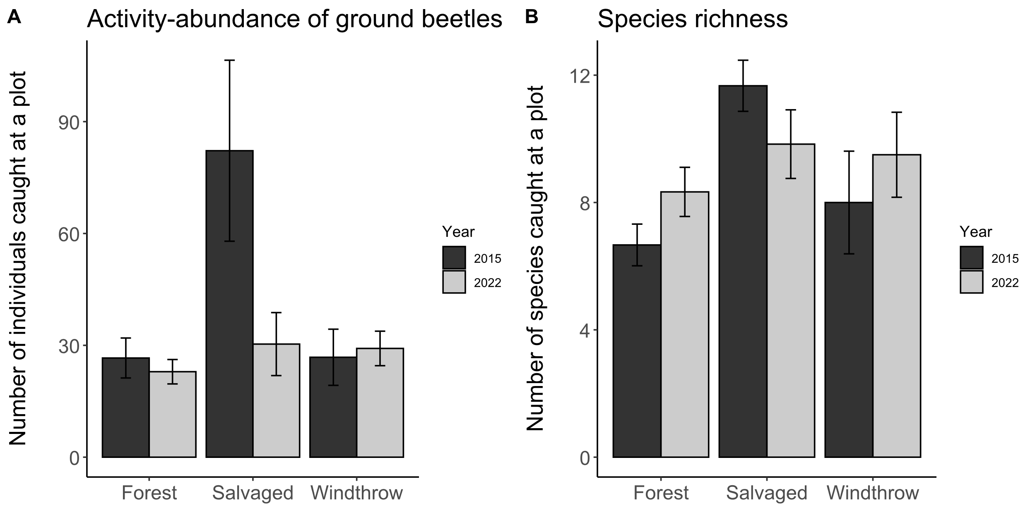

**Figure ___.** Activity-abundance and taxonomic species richness of ground beetles in 24 plots. Bar height is the group mean, and whiskers indicate the standard error of the mean. Each bar has a sample size of 6 plots each for salvaged or windthrow, and 12 plots for the forest control.

.

The principal components analysis (PCA) of the eight numerical traits generated a set of four axes which together explained 83% of the variance. The first PC axis (31% of the variance) was associated with proportionally narrower pronotum (relative to body length), proportionally longer rear legs, and proportionally shorter rear trochanter (Figure ____, Table _____). The second PC axis (25% of the variance) was associated with longer body length, proportionally shorter eye length, and smaller (antenna length):(rear leg length) ratio. The third PC axis (16% of the variance) was associated with proportionally wider abdomen and larger eye protrusion ratio. The fourth PC axis (11% of the variance) was associated with proportionally longer eyes, proportionally longer rear legs, and proportionally longer rear trochanters.

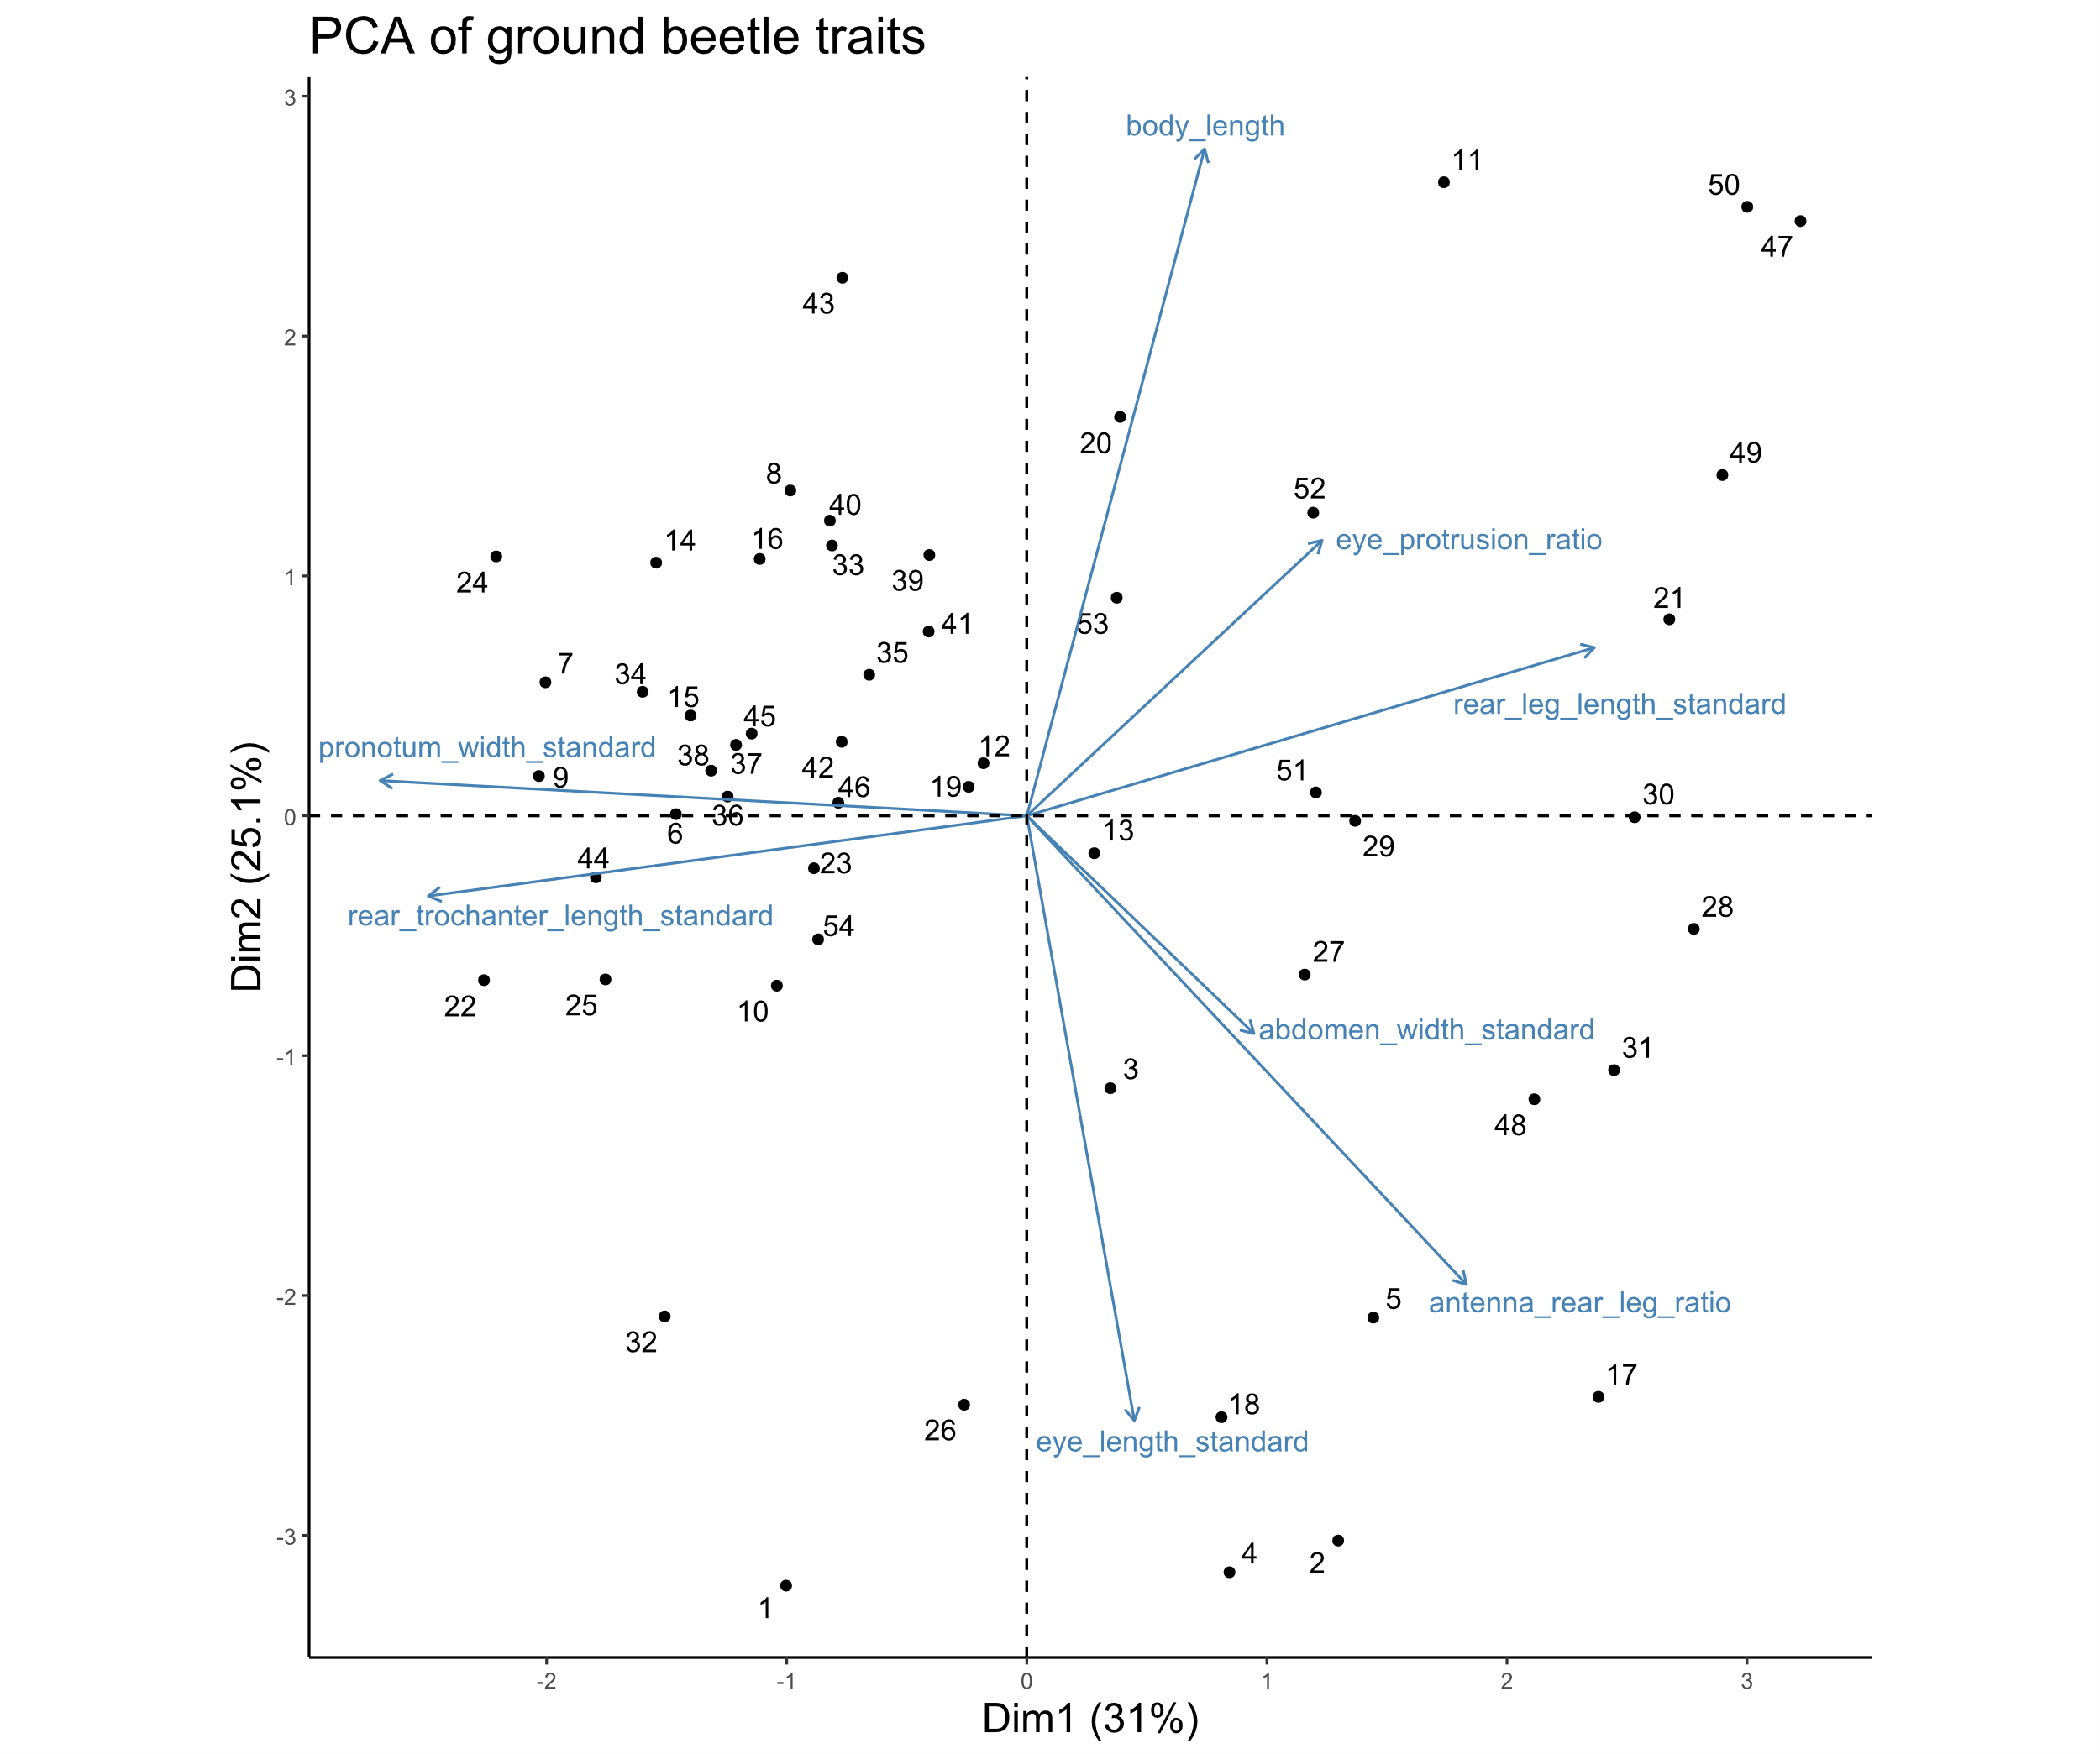

**Figure ____.** Biplot of the first two principal component axes of the PCA of the eight numerical traits measured for 54 ground beetle species. The species *Notiophilus aeneus* was omitted from the analysis. Numbers from 1 to 54 indicate species, which are listed in Table _____. Blue arrows with labels are the eight trait variables. The word “standard” after a variable name indicates that it has previously been divided by body length to address high correlations with body length.

**Table _____.** Loading values for the principal components analysis of eight numerical traits. The word “standard” after a variable name indicates that it has previously been divided by body length to address high correlations with body length. Eye protrusion ratio is equal to eye protrusion divided by eye length. Antenna rear leg ratio is equal to antenna length divided by rear leg length.

|  |  |  |  |  |  |  |  |  |
| --- | --- | --- | --- | --- | --- | --- | --- | --- |
| Trait | PC1 | PC2 | PC3 | PC4 | PC5 | PC6 | PC7 | PC8 |
| body_length | 0.15 | 0.61 | -0.10 | 0.27 | 0.06 | 0.19 | 0.57 | -0.39 |
| eye_length_standard | 0.09 | -0.55 | -0.07 | 0.52 | 0.21 | -0.37 | 0.10 | -0.46 |
| eye_protrusion_ratio | 0.24 | 0.25 | 0.58 | -0.02 | 0.68 | -0.17 | -0.22 | 0.03 |
| pronotum_width_standard | -0.53 | 0.03 | 0.36 | 0.03 | -0.12 | 0.36 | -0.35 | -0.57 |
| abdomen_width_standard | 0.19 | -0.20 | 0.70 | 0.25 | -0.45 | 0.11 | 0.33 | 0.23 |
| rear_leg_length_standard | 0.47 | 0.15 | -0.17 | 0.51 | -0.18 | 0.30 | -0.58 | 0.07 |
| antenna_rear_leg_ratio | 0.36 | -0.43 | -0.05 | -0.31 | 0.29 | 0.68 | 0.15 | -0.14 |
| rear_trochanter_length_standard | -0.49 | -0.07 | -0.08 | 0.48 | 0.39 | 0.34 | 0.14 | 0.48 |

The functional alpha-diversity, as measured by mean pairwise distance in trait space of species found within each plot, did not differ significantly by forest management treatment, year, or their interaction (Table ____). However, key axes of morphological variation showed differences in community-weighted means (CWMs) based on treatment. Ground beetles caught in salvaged plots tended to have lower values of PC1 (t=4.139, p=0.001), lower values of PC2 (t=4.986, p<0.001), and lower values of PC3 (t=2.707, p=0.027) than ground beetles caught in forest control plots. Additionally, those caught in salvaged plots tended to have lower values of PC2 than those caught in windthrow plots (t=2.522, p=0.042).

When individual functional traits of ground beetles were examined, some traits exhibited differences based on treatment, year, or their interaction. First, the body length tended to be shorter for beetles caught in the salvaged plots, relative to those caught in the forest control (t=3.189, p=0.007). Second, beetles caught in salvaged plots typically had proportionally longer eyes relative to their body size than beetles caught in forest (t=3.963, p=0.001) or windthrow (t=2.814, p=0.021). Not only did they tend to have proportionally longer eyes, but beetles caught in salvaged plots tended to have eyes with a lower (eye protrusion / eye length) ratio than forest (t=5.582, p<0.001) or windthrow (t=2.812, p=0.021), meaning their eyes were flatter or oblong, whereas species caught in forest controls tended to have more spherical eyes. There were also differences in the structure of the rear legs. Beetles in salvaged plots often had rear trochanters that were longer in proportion to body length than those caught in forest (t=4.749, p<0.001) or windthrow plots (t=3.084, p=0.011). In 2015, those caught in salvaged plots were more likely to be capable of flight than those caught in forest controls (t=4.136, p=0.001) or windthrow (t=3.166, p=0.009). While the abundance of flight-capable species spiked in salvage-logged plots in 2015, it returned to lower levels by 2022. Another change which occurred between 2015 and 2022 is the antenna length / rear leg length ratio decreased (F=5.737, p=0.021).

**Table ____.** Summary of the ANOVA tests on plot-level metrics of ground beetle biodiversity and environmental variables. The model type column indicates if the model was a standard linear model (LM), a linear mixed-effects model with transect included as a random effect (LMM), or a generalized linear model with Poisson errors (GLM). CWM stands for community weighted mean.

|  |  |  |  |  |  |  |  |  |
| --- | --- | --- | --- | --- | --- | --- | --- | --- |
| Response variable |  | Model  type | Treatment  (Forest, Salvaged, Windthrow) | | Year (2015, 2022) | | Treatment*Year interaction | |
|  |  |  |  | |  | |  |  |
|  |  |  | Statistic | p | Statistic | p | Statistic | p |
|  |  |  |  |  |  |  |  |  |
| Total activity-abundance |  | LMM* | **F= 5.680** | **0.007** | F=1.870 | 0.180 | **F=4.490** | **0.018** |
| Activity abundance of open-habitat and eurytopic species |  | LMM* | **F=3.601** | **0.037** | F=0.009 | 0.922 | F=2.410 | 0.104 |
| Activity abundance of forest-specialist species |  | LMM* | F=0.729 | 0.489 | F=3.367 | 0.075 | F=2.715 | 0.079 |
| Species richness |  | GLM | **X2=11.464** | **0.003** | X2=2.227 | 0.136 | X2=3.156 | 0.206 |
| Shannon diversity |  | LMM | F= 0.970 | 0.389 | F= 1.319 | 0.258 | F= 0.229 | 0.796 |
| Functional alpha-diversity |  | LM | F= 0.211 | 0.811 | F= 0.261 | 0.613 | F= 1.484 | 0.238 |
| Community-weighted mean (CWM) principal component (PC) 1 |  | LMM | **F= 8.570** | **0.001** | F= 2.001 | 0.166 | F= 0.505 | 0.608 |
| CWM PC2 |  | LMM | **F=** **12.525** | **<0.001** | F=0.525 | 0.473 | F= 1.280 | 0.290 |
| CWM PC3 |  | LMM | **F=** **3.695** | **0.034** | F= 0.337 | 0.565 | F=0.534 | 0.591 |
| CWM Body length |  | LM | **F=5.763** | **0.006** | F=2.610 | 0.114 | F=0.251 | 0.779 |
| CWM Standardized antenna length |  | LMM | F=0.567 | 0.572 | F=3.907 | 0.056 | F=2.031 | 0.146 |
| CWM Standardized rear leg length |  | LMM | F=0.411 | 0.666 | F=1.614 | 0.212 | F=1.872 | 0.168 |
| CWM Antenna length : Rear leg length ratio |  | LM | F=0.360 | 0.700 | **F=5.737** | **0.021** | F=0.517 | 0.600 |
| CWM Standardized eye length |  | LMM | **F=8.060** | **0.001** | F=0.029 | 0.866 | F=1.263 | 0.295 |
| CWM Standardized eye protrusion |  | LMM | F= 1.881 | 0.167 | F= 0.269 | 0.607 | F= 0.897 | 0.417 |
| CWM eye protrusion : eye length ratio |  | LMM | **F= 15.706** | **<0.001** | F= 2.752 | 0.106 | F= 0.576 | 0.567 |
| CWM Standardized pronotum width |  | LMM | F= 1.199 | 0.313 | F= 1.152 | 0.290 | F= 0.046 | 0.956 |
| CWM Standardized abdomen width |  | LMM | F= 0.419 | 0.661 | F= 0.570 | 0.455 | F= 0.634 | 0.536 |
| CWM Standardized rear trochanter length |  | LMM | **F= 11.363** | **<0.001** | F= 0.046 | 0.831 | F= 1.433 | 0.252 |
| CWM Water affinity |  | LM | F=0.101 | 0.904 | F= 0.107 | 0.745 | F= 2.655 | 0.080 |
| CWM Flight capability |  | LMM* | **F= 5.712** | **0.007** | F= 3.536 | 0.068 | **F= 3.928** | **0.028** |
| Vegetation percentage cover |  | LMM | **F=15.565** | **<0.001** | F=0.657 | 0.423 | **F=5.669** | **0.007** |
| Leaf litter percentage cover |  | LMM | **F=20.0451** | **<0.001** | F= 0.800 | 0.377 | **F=8.771** | **0.001** |
| Canopy openness |  | LMM* | **F=47.169** | **<0.001** | **F=45.857** | **<0.001** | **F=19.864** | **<0.001** |
| Soil moisture (2015) |  | LMM | F=0.0792 | 0.9242 | NA | NA | NA | NA |
| Soil moisture (2022) |  | LMM | F=0.2342 | 0.7939 | NA | NA | NA | NA |

*: a log transformation was done on the response variable to improve the model’s satisfaction of assumptions

**Table ______.** Means (± standard errors) of the response variables for ground beetle biodiversity and environmental variables.

|  |  |  |  |  |  |  |  |
| --- | --- | --- | --- | --- | --- | --- | --- |
|  |  | Unit |  | Year | Forest | Salvaged | Windthrow |
| Sample size |  | Plots |  | 2015 | n=12 | n=6 | n=6 |
|  |  |  |  | 2022 | n=12 | n=6 | n=6 |
|  |  |  |  |  |  |  |  |
| Total activity-abundance |  | Beetles per 84 days |  | 2015 | 26.6 ± 5.4 | 82.2 ± 24.3 | 26.8 ± 7.5 |
|  |  |  |  | 2022 | 22.9 ± 3.3 | 30.3 ± 8.4 | 29.2 ± 4.6 |
|  |  |  |  |  |  |  |  |
| Activity abundance of open-habitat species |  | Beetles per 84 days |  | 2015 | 0 ± 0 | 0.90 ± 0.32 | 0 ± 0 |
|  |  |  |  | 2022 | 0.23 ± 0.15 | 0.67 ± 0.67 | 0 ± 0 |
|  |  |  |  |  |  |  |  |
| Activity abundance of eurytopic species |  | Beetles per 84 days |  | 2015 | 12.7 ± 3.1 | 44.2 ± 15.4 | 12.4 ± 3.6 |
|  |  |  |  | 2022 | 11.1 ± 1.4 | 20.2 ± 8.7 | 15.5 ± 3.6 |
|  |  |  |  |  |  |  |  |
| Activity abundance of forest-specialist species |  | Beetles per 84 days |  | 2015 | 13.9 ± 2.8 | 37.1 ± 14.3 | 14.3 ± 4.2 |
|  |  |  |  | 2022 | 11.6 ± 2.1 | 9.3 ± 1.9 | 13.7 ± 3.2 |
|  |  |  |  |  |  |  |  |
| Species richness |  | Number of species |  | 2015 | 6.7 ± 0.7 | 11.7 ± 0.8 | 8.0 ± 1.6 |
|  |  |  |  | 2022 | 8.3 ± 0.8 | 9.8 ± 1.1 | 9.5 ± 1.3 |
|  |  |  |  |  |  |  |  |
| Shannon diversity |  | Effective number of species |  | 2015 | 5.1 ± 0.5 | 6.3 ± 1.0 | 6.5 ± 1.2 |
|  |  |  |  | 2022 | 6.4 ± 0.6 | 6.7 ± 1.0 | 7.0 ± 0.9 |
|  |  |  |  |  |  |  |  |
| Functional alpha-diversity |  | Within-plot mean pairwise distance in trait space |  | 2015 | 0.15 ± 0.01 | 0.18 ± 0.01 | 0.16 ± 0.02 |
|  |  |  |  | 2022 | 0.17 ± 0.01 | 0.16 ± 0.01 | 0.17 ± 0.01 |
|  |  |  |  |  |  |  |  |
| CWM PC1 |  | No unit |  | 2015 | 0.29 ± 0.11 | -0.21 ± 0.09 | -0.01 ± 0.17 |
|  |  |  |  | 2022 | 0.07 ± 0.12 | -0.45 ± 0.15 | 0.00 ± 0.11 |
|  |  |  |  |  |  |  |  |
| CWM PC2 |  | No unit |  | 2015 | 1.21 ± 0.12 | 0.49 ± 0.16 | 0.90 ± 0.12 |
|  |  |  |  | 2022 | 0.97 ± 0.11 | 0.59 ± 0.13 | 0.83 ± 0.06 |
|  |  |  |  |  |  |  |  |
| CWM PC3 |  | No unit |  | 2015 | -0.27 ± 0.08 | -0.62 ± 0.16 | -0.45 ± 0.14 |
|  |  |  |  | 2022 | -0.33 ± 0.09 | -0.55 ± 0.11 | -0.30 ± 0.11 |
|  |  |  |  |  |  |  |  |
| CWM Body length |  | mm |  | 2015 | 17.32 ± 0.47 | 15.61 ± 0.53 | 16.09 ± 0.50 |
|  |  |  |  | 2022 | 16.46 ± 0.38 | 15.29 ± 0.37 | 15.74 ± 0.15 |
|  |  |  |  |  |  |  |  |
| CWM Standardized antenna length |  | Fraction of body length |  | 2015 | 0.453 ± 0.007 | 0.458 ± 0.011 | 0.444 ± 0.013 |
|  |  |  |  | 2022 | 0.445 ± 0.008 | 0.423 ± 0.005 | 0.446 ± 0.006 |
|  |  |  |  |  |  |  |  |
| CWM Standardized rear leg length |  | Fraction of body length |  | 2015 | 0.744 ± 0.013 | 0.752 ± 0.013 | 0.731 ± 0.014 |
|  |  |  |  | 2022 | 0.739 ± 0.009 | 0.712 ± 0.008 | 0.740 ± 0.006 |
|  |  |  |  |  |  |  |  |
| CWM Antenna length : Rear leg length ratio |  | Fraction of rear leg length |  | 2015 | 0.607 ± 0.004 | 0.608 ± 0.004 | 0.606 ± 0.008 |
|  |  |  |  | 2022 | 0.6 ± 0.004 | 0.592 ± 0.003 | 0.6 ± 0.005 |
|  |  |  |  |  |  |  |  |
| CWM Standardized eye length |  | Fraction of body length |  | 2015 | 0.045 ± 0.001 | 0.05 ± 0.001 | 0.046 ± 0.001 |
|  |  |  |  | 2022 | 0.046 ± 0.001 | 0.049 ± 0.001 | 0.047 ± 0.001 |
|  |  |  |  |  |  |  |  |
| CWM Standardized eye protrusion |  | Fraction of body length |  | 2015 | 0.051 ± 0.001 | 0.054 ± 0.001 | 0.052 ± 0.001 |
|  |  |  |  | 2022 | 0.052 ± 0.001 | 0.053 ± 0.001 | 0.052 ± 0.000 |
|  |  |  |  |  |  |  |  |
| CWM eye protrusion : eye length ratio |  | Fraction of eye length |  | 2015 | 1.146 ± 0.007 | 1.096 ± 0.008 | 1.119 ± 0.012 |
|  |  |  |  | 2022 | 1.126 ± 0.007 | 1.087 ± 0.01 | 1.115 ± 0.007 |
|  |  |  |  |  |  |  |  |
| CWM Standardized pronotum width |  | Fraction of body length |  | 2015 | 0.262 ± 0.003 | 0.265 ± 0.002 | 0.263 ± 0.002 |
|  |  |  |  | 2022 | 0.264 ± 0.001 | 0.268 ± 0.002 | 0.265 ± 0.001 |
|  |  |  |  |  |  |  |  |
| CWM Standardized abdomen width |  | Fraction of body length |  | 2015 | 0.353 ± 0.004 | 0.351 ± 0.005 | 0.349 ± 0.006 |
|  |  |  |  | 2022 | 0.354 ± 0.003 | 0.349 ± 0.003 | 0.357 ± 0.003 |
|  |  |  |  |  |  |  |  |
| CWM Standardized rear trochanter length |  | Fraction of body length |  | 2015 | 0.098 ± 0.002 | 0.113 ± 0.003 | 0.103 ± 0.003 |
|  |  |  |  | 2022 | 0.102 ± 0.002 | 0.109 ± 0.003 | 0.103 ± 0.002 |
|  |  |  |  |  |  |  |  |
| CWM Water affinity |  | 0, 0.5, or 1 |  | 2015 | 0.79 ± 0.03 | 0.80 ± 0.05 | 0.71 ± 0.03 |
|  |  |  |  | 2022 | 0.74 ± 0.03 | 0.76 ± 0.03 | 0.81 ± 0.03 |
|  |  |  |  |  |  |  |  |
| CWM Flight capability |  | 0, 0.5, or 1 |  | 2015 | 0.08 ± 0.04 | 0.30 ± 0.07 | 0.08 ± 0.04 |
|  |  |  |  | 2022 | 0.05 ± 0.01 | 0.08 ± 0.04 | 0.09 ± 0.03 |
|  |  |  |  |  |  |  |  |
| Soil moisture$ |  | 0-1 |  | 2015 | 0.59 ± 0.04 | 0.61 ± 0.07 | 0.60 ± 0.04 |
|  |  | 0-100% |  | 2022 | 44.82 ± 3.51 | 47.64 ± 2.54 | 48.66 ± 7.41 |
|  |  |  |  |  |  |  |  |
| Ground-level vegetation percentage cover |  | 0-100% |  | 2015 | 21.6 ± 2.8 | 73.0 ± 6.0 | 42.1 ± 10.4 |
|  |  |  |  | 2022 | 35.1 ± 4.2 | 47.7 ± 11.3 | 41.9 ± 6.7 |
|  |  |  |  |  |  |  |  |
| Leaf litter percentage cover |  | 0-100% |  | 2015 | 61.2 ± 3.6 | 5.2 ± 3.5 | 35.4 ± 7.3 |
|  |  |  |  | 2022 | 43.1 ± 4.5 | 31.5 ± 9.5 | 39.6 ± 5.8 |
|  |  |  |  |  |  |  |  |
| Canopy openness |  | 0-100% |  | 2015 | 9.1 ± 0.4 | 82.3 ± 3.4 | 13.7 ± 2.5 |
|  |  |  |  | 2022 | 7.7 ± 0.5 | 19.7 ± 10.8 | 9.1 ± 1.3 |

$: A different soil sensor was used in 2022 than was used in 2015, so readings are only comparable between treatments within a year.

We found evidence of beta-diversity between the 24 plots, and that this beta-diversity could be partially explained by forest management treatment (forest, salvaged, windthrow). PERMANOVAs indicated that treatments differed significantly in species composition (F=1.745, p=0.024) and trait composition (F=1.789, p=0.001). Salvaged plots differed in species composition from forest controls (F=2.414, p=0.045), and in trait composition from forest controls (F=2.615, p=0.006) and windthrow plots (F=1.613, p=0.045). The species composition significantly differed between 2015 and 2022 (F=3.803, p=0.001), but the trait composition did not differ significantly between years (F=1.263, p=0.111), and interactions between treatment and year were not significant. Analysis of the dispersion from group centers did not find significant differences in dispersion by treatment or year. The NMDS ordinations resulted in stress values of 0.224 for taxonomic beta-diversity and 0.186 for functional beta-diversity.

Investigation of environmental variables on the forest floor found differences based on forest management treatment that also changed from 2015 to 2022 (Table ____). Canopy openness above the pitfall traps differed by treatment (F=47.169, p<0.001), by year (F=45.857, p<0.001), and by treatment:year interaction (F=19.864, p<0.001). Salvaged plots had higher canopy openness than forest controls in both years (2015: t=11.124, p<0.001; 2022: t=2.44, p=0.050), and salvaged plots also had higher canopy openness than windthrow plots in 2015 (t=8.128, p<0.001). Canopy openness decreased between 2015 and 2022 for the salvaged plots (t=8.296, p<0.001). Ground cover on the forest floor also differed by treatment and by treatment:year interaction. In 2015, the percentage cover of ground-level vegetation was highest in salvaged plots, intermediate in windthrow plots, and lowest in forest controls (F-S: t=6.307, p<0.001; F-W: t=2.510, p=0.043; S-W: t=3.289, p=0.006). Between 2015 and 2022, ground-level vegetation percentage decreased in salvaged plots (t=2.691, p=0.011), such that there were no significant treatment differences in 2022. Leaf litter percentage cover showed an opposite pattern to vegetation: in 2015 leaf litter percentage was lowest in the salvaged plots, intermediate in windthrows, and highest in forest controls (F-S: t=7.368, p<0.001, F-W: t=3.389, p=0.005; S-W: t=3.446, p=0.004). Between 2015 and 2022, leaf litter percentage increased in salvaged plots (t=2.994, p=0.005), and decreased in forest controls (t=2.907, p=0.006). Soil moisture did not vary by treatment in either 2015 (F=0.079, p=0.924) or 2022 (F=0.234, p=0.794).

**Discussion**

The results show evidence that a few ground beetle species greatly benefited from salvage-logging after windthrow. The activity-abundance of ground beetles was higher in salvaged plots than windthrow or forest control plots in 2015, which was three years after the tornado and two years after the salvage-logging. However, by 2022, nine years after salvage-logging, the activity-abundance of ground beetles in salvage-logged plots was no longer elevated as it was in 2015. Furthermore, our analysis revealed that salvage-logged plots tended to have a higher species richness of ground beetles than forest control plots, at least at two years post-disturbance.

The analysis of ground beetle traits revealed that species caught in salvaged locations tended to have certain traits which may increase their fitness in disturbed environments. Beetles caught in salvaged plots tended to have smaller bodies, tended to have larger eyes proportional to their body size, and tended to have flatter eyes. Furthermore, species caught in salvaged plots often had longer hind trochanters relative to their body size, and were more likely to be capable of flight. It is important to note that there are exceptions to all these trends.

In addition to patterns with individual traits, we investigated the possibility that morphological traits could be related to one another and exist as trait syndromes. We found evidence that ground beetles with proportionally longer legs also had proportionally longer antennae. Furthermore, these long-legged species also tended to have proportionally narrower pronota and proportionally shorter rear trochanters. This syndrome is likely associated with locomotion strategy: beetle species that run on the ground surface may benefit from longer legs to move faster or climb over obstacles. In contrast, beetles that move through substrates like soil or ground fissures use their short legs to generate stronger pushing forces. Short and wide hind femora have been associated with stronger horizontal pushing forces in ground beetles, as the femur houses muscles that flex and extend the tibia (Forsythe 1981). Furthermore, longer hind trochanters are associated with stronger vertical (ie. in the dorsal direction) pushing, because the hind trochanter houses the femoral rotator muscle which helps push the tarsi downwards. In fact, ground beetles may use a burrowing strategy called “oscillatory wedge pushing” where their pronotum and head act as a wedge, while their abdomen moves back and forth in order to move through a constricted area such as between layers of leaf litter, soil, or underneath bark.

IDEAS:

Although the percent cover of woody debris did not differ between the windthrow and salvaged treatments, there was higher volume of coarse woody debris in the windthrow in 2014, compared to the salvaged treatment (Perry 2016). The reduction in coarse woody debris volume in the salvaged treatment could last decades. When examining clearcut stands of varying age in New Hampshire, researchers found that the slash from clearcutting decomposed within 20-30 years, leaving low mass of downed wood for an additional 30 years, before the tree regeneration began to contribute downed wood (Gore and Patterson III 1986). Thus, salvage-logging could affect woody debris volume for >50 years.

It must be mentioned that just because a ground beetle was caught in a given forest disturbance treatment doesn’t mean that it spent the entire year at that location. Ground beetles, even flightless species, can move fairly long distances over the seasons (cite). For example, some ground beetle species forage for prey in the summer within agricultural fields but move to woodlot edges to overwinter (cite). Thus, the fact that many forest ground beetles like ____ and ____ were still caught in salvage-logged areas does not rule out that they could still need the mature forest for part of the year.

**Supplementary information**

Omission of the final two sampling intervals of 2022

In 2022, pitfall traps were sampled into September, but these final two sample intervals were omitted from the analysis. Because we only had September data in 2022, but not for 2015, we decided to omit the September 2022 data to ensure that the two years could be comparable. The species composition of ground beetles found in pitfall traps changed in September. For example, the following species were found only in September 2022, and not earlier in 2022 or in 2015: *Amerizus* sp. (Bembidiini), *Myas coracinus*, *Patrobus longicornis*, *Platynus hypolithos*, *Pterostichus atratus*, *Scaphinotus andrewsii*, *Scaphinotus ridingsii*, *Synuchus impunctatus*. Furthermore, the abundance of some species, including *Platynus angustatus*, greatly increased in September (Figure S____). This evidence further justifies our omission of the final two sample intervals of 2022 from the statistical analysis. The species captured only in September were still included in the principal components analysis of traits but were not included in any statistical analyses.

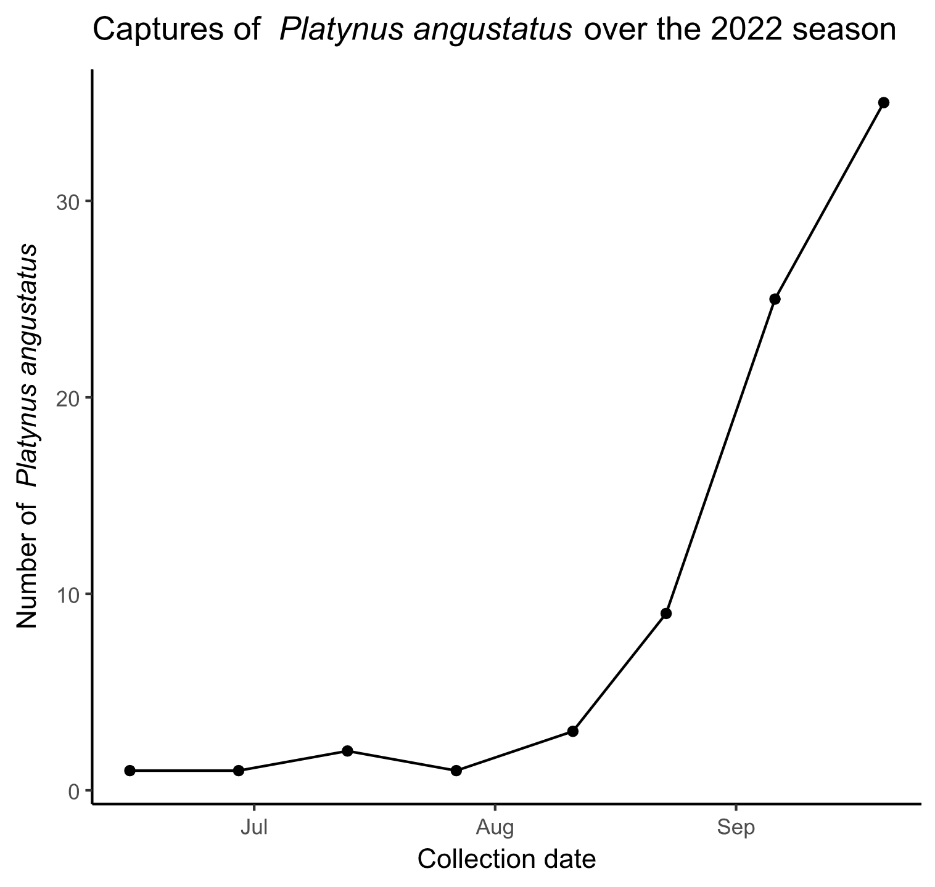

**Figure S___.** Captures of *Platynus angustatus* over the 2022 season in all pitfall traps. The x-axis shows the date of collection, while the y-axis shows number of *P. angustatus* captured during the sample interval.

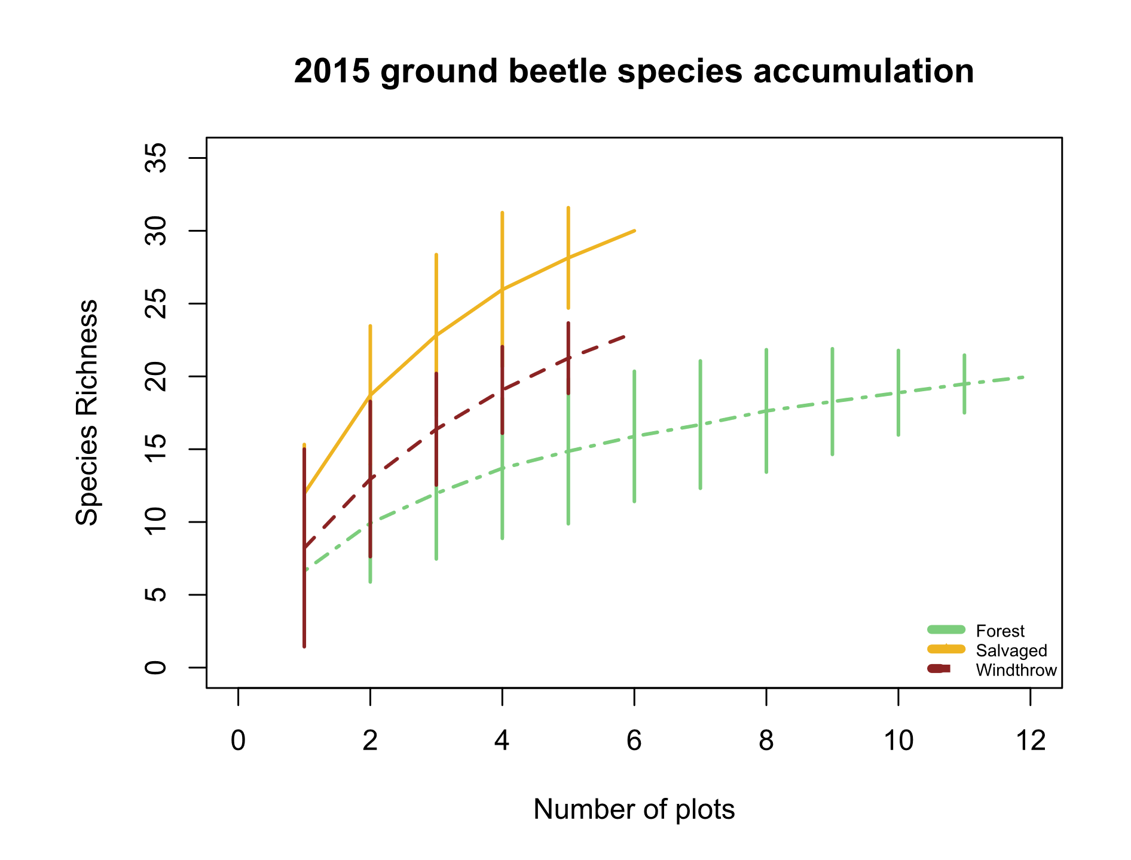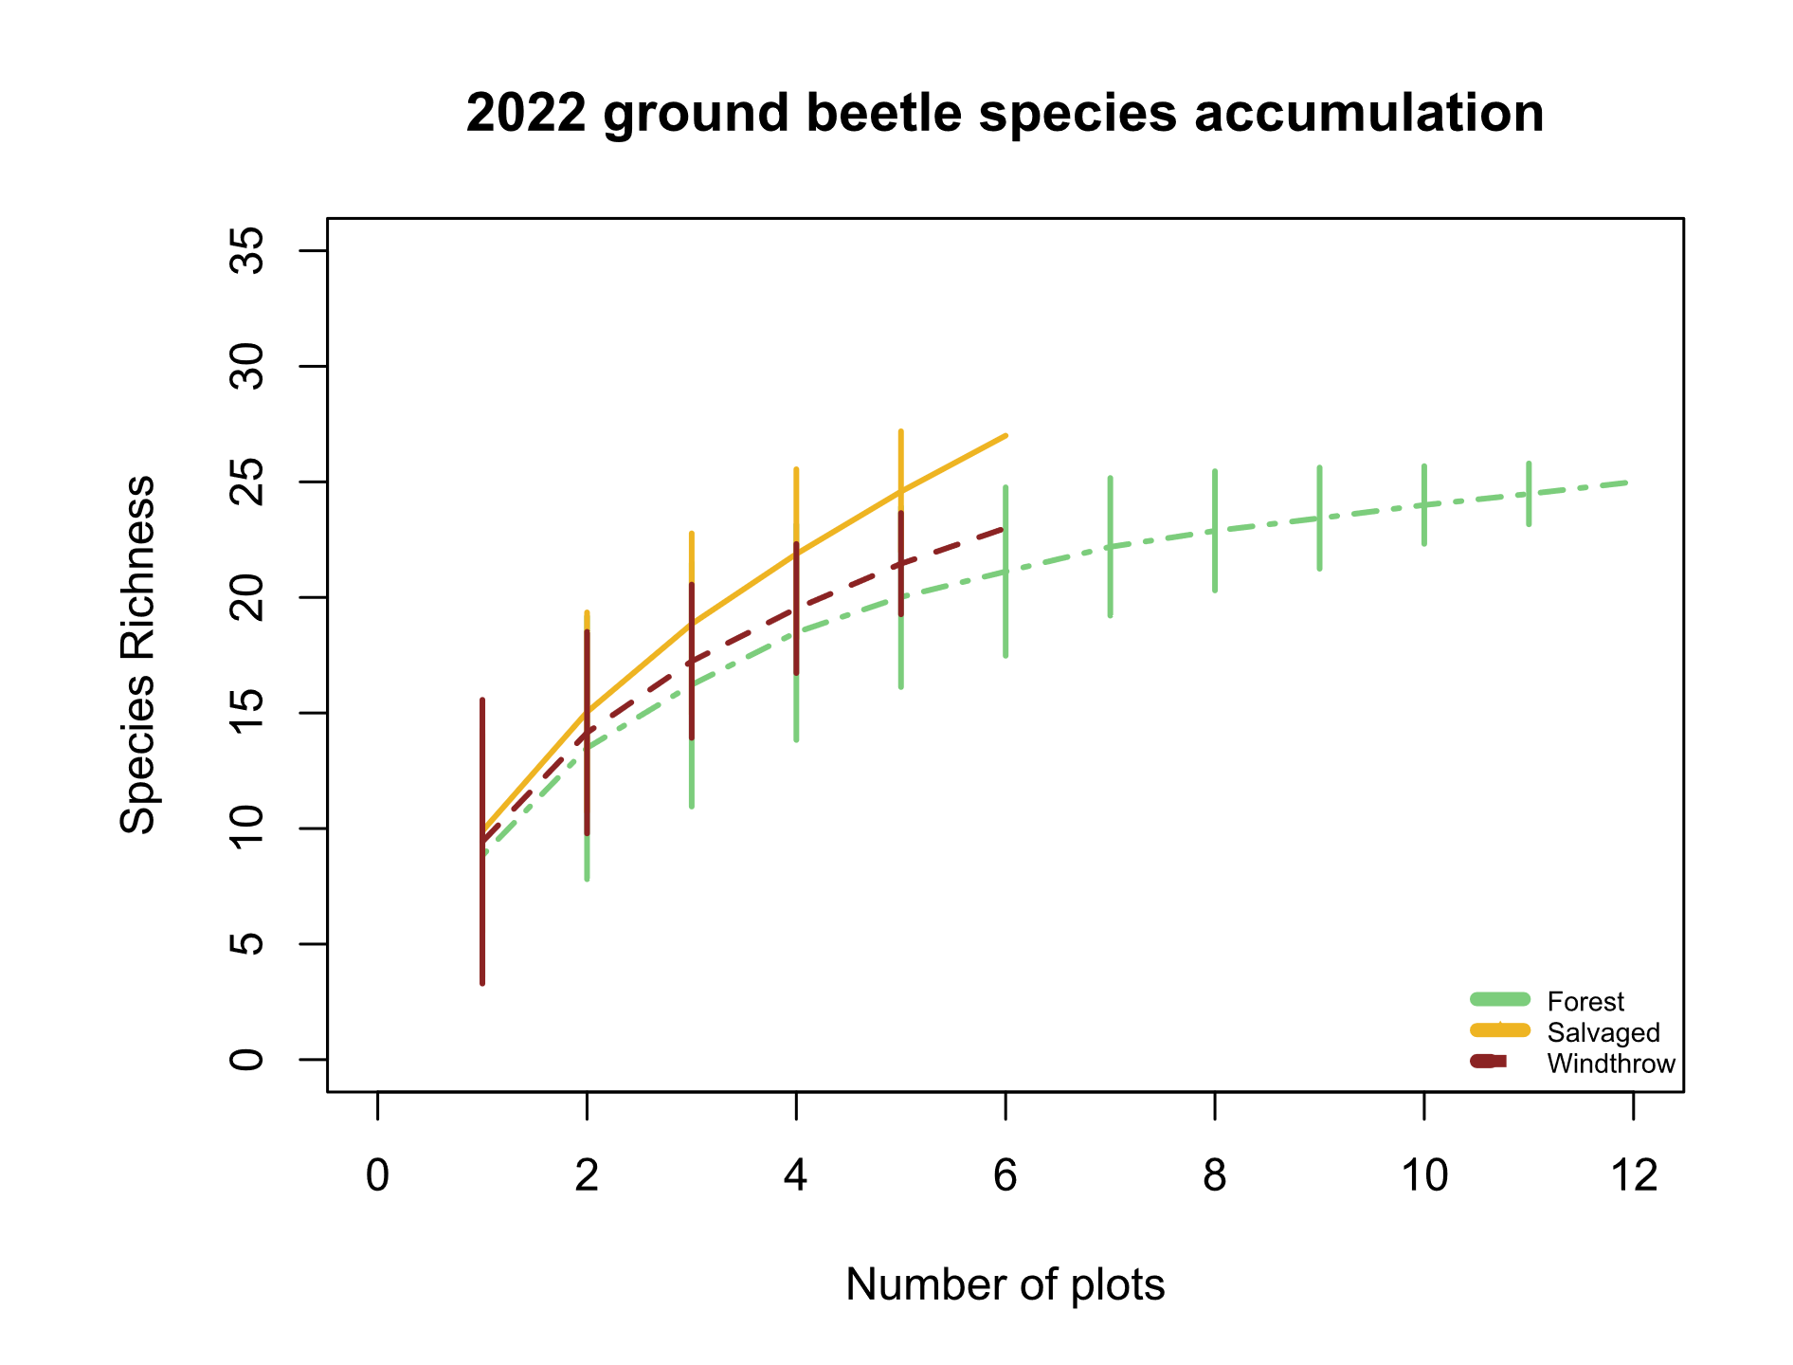

B

A

**Figure S____.** Species accumulation curves for A) 2015 ground beetles and B) 2022 ground beetles. The x-axis shows the number of sampled plots, while the y-axis shows the species richness.

**Table S1.** Voucher specimens used for trait measurements in this study. The Unique ID begins with “OSUC” if the specimen was already in the Ohio State University Triplehorn Insect Collection from 2015 or a previous study, whereas Unique IDs with just a number indicate 2022 specimens which will be vouchered as part of this study.

|  |  |  |  |
| --- | --- | --- | --- |
| Species | Sex | Unique ID | Location of collection |
| *Agonoleptus thoracicus* | f | 819611 | Powdermill |
| *Agonum ferreum* | m | OSUC 671705 | Powdermill |
| *Agonum ferreum* | m | OSUC 671700 | Powdermill |
| *Agonum ferreum* | f | OSUC 671704 | Powdermill |
| *Agonum ferreum* | f | OSUC 671703 | Powdermill |
| *Agonum ferreum* | f | OSUC 671702 | Powdermill |
| *Agonum fidele* | f | 819619 | Powdermill |
| *Agonum fidele* | f | 819616 | Powdermill |
| *Agonum fidele* | f | 819613 | Powdermill |
| *Agonum retractum* | m | OSUC 671697 | Powdermill |
| *Agonum retractum* | f | OSUC 523212 | Erie Co. OH |
| *Agonum retractum* | f | OSUC 523213 | Erie Co. OH |
| *Agonum retractum* | f | OSUC 523214 | Erie Co. OH |
| *Amerizus sp.* | m | 819614 | Powdermill |
| *Amphasia interstitialis* | m | Not vouchered | Powdermill |
| *Amphasia interstitialis* | f | Not vouchered | Powdermill |
| *Amphasia interstitialis* | f | Not vouchered | Powdermill |
| *Amphasia interstitialis* | f | Not vouchered | Powdermill |
| *Anisodactylus harrisii* | m | OSUC 671671 | Powdermill |
| *Anisodactylus harrisii* | m | OSUC 740908 | Cuyahoga Co. OH |
| *Anisodactylus harrisii* | m | OSUC 740906 | Cuyahoga Co. OH |
| *Anisodactylus harrisii* | f | 819778 | Powdermill |
| *Anisodactylus harrisii* | f | OSUC 740902 | Cuyahoga Co. OH |
| *Anisodactylus harrisii* | f | OSUC 740900 | Cuyahoga Co. OH |
| *Anisodactylus melanopus* | m | 819699 | Powdermill |
| *Anisodactylus nigerrimus* | m | 819634 | Powdermill |
| *Anisodactylus nigerrimus* | m | 819631 | Powdermill |
| *Anisodactylus nigerrimus* | m | 819628 | Powdermill |
| *Anisodactylus nigerrimus* | f | 819625 | Powdermill |
| *Anisodactylus nigerrimus* | f | 819622 | Powdermill |
| *Apenes lucidula* | m | 819706 | Powdermill |
| *Apenes lucidula* | m | 819715 | Powdermill |
| *Apenes lucidula* | f | 819707 | Powdermill |
| *Apenes lucidula* | f | 819716 | Powdermill |
| *Apenes lucidula* | f | 819724 | Powdermill |
| *Carabus goryi* | m | 819636 | Powdermill |
| *Carabus goryi* | m | 819639 | Powdermill |
| *Carabus goryi* | m | 819642 | Powdermill |
| *Carabus goryi* | f | 819645 | Powdermill |
| *Carabus goryi* | f | 819648 | Powdermill |
| *Carabus goryi* | f | 819651 | Powdermill |
| *Chlaenius emarginatus* | m | 819704 | Powdermill |
| *Chlaenius emarginatus* | m | 819713 | Powdermill |
| *Chlaenius emarginatus* | m | 819722 | Powdermill |
| *Chlaenius emarginatus* | f | 819705 | Powdermill |
| *Chlaenius emarginatus* | f | 819714 | Powdermill |
| *Chlaenius emarginatus* | f | 819723 | Powdermill |
| *Chlaenius laticollis* | f | OSUC 671794 | Powdermill |
| *Chlaenius laticollis* | f | OSUC 671795 | Powdermill |
| *Cyclotrachelus convivus* | m | OSUC 671699 | Powdermill |
| *Cyclotrachelus convivus* | m | OSUC 522517 | Erie Co. OH |
| *Cyclotrachelus convivus* | m | OSUC 740962 | Cuyahoga Co. OH |
| *Cyclotrachelus convivus* | f | OSUC 522528 | Erie Co. OH |
| *Cyclotrachelus convivus* | f | OSUC 522527 | Erie Co. OH |
| *Cyclotrachelus convivus* | f | OSUC 522525 | Erie Co. OH |
| *Cyclotrachelus fucatus* | m | 819782 | Powdermill |
| *Cyclotrachelus sigillatus* | m | 819753 | Powdermill |
| *Cyclotrachelus sigillatus* | m | 819763 | Powdermill |
| *Cyclotrachelus sigillatus* | m | 819773 | Powdermill |
| *Cyclotrachelus sigillatus* | f | 819754 | Powdermill |
| *Cyclotrachelus sigillatus* | f | 819764 | Powdermill |
| *Cyclotrachelus sigillatus* | f | 819774 | Powdermill |
| *Cymindis limbata* | unknown sex | 819617 | Powdermill |
| *Cymindis platicollis* | unknown sex | 819777 | Powdermill |
| *Dicaelus politus* | m | 819708 | Powdermill |
| *Dicaelus politus* | m | 819717 | Powdermill |
| *Dicaelus politus* | m | 819725 | Powdermill |
| *Dicaelus politus* | f | 819709 | Powdermill |
| *Dicaelus politus* | f | 819718 | Powdermill |
| *Dicaelus politus* | f | 819726 | Powdermill |
| *Dicaelus teter* | m | 819604 | Powdermill |
| *Dicaelus teter* | m | 819719 | Powdermill |
| *Dicaelus teter* | m | 819727 | Powdermill |
| *Dicaelus teter* | f | 819710 | Powdermill |
| *Dicaelus teter* | f | 819720 | Powdermill |
| *Dicaelus teter* | f | 819728 | Powdermill |
| *Galerita bicolor* | f | 819640 | Powdermill |
| *Galerita bicolor* | f | 819637 | Powdermill |
| *Harpalus spadiceus* | m | 819658 | Powdermill |
| *Harpalus spadiceus* | m | 819655 | Powdermill |
| *Harpalus spadiceus* | m | 819652 | Powdermill |
| *Harpalus spadiceus* | f | 819649 | Powdermill |
| *Harpalus spadiceus* | f | 819646 | Powdermill |
| *Harpalus spadiceus* | f | 819643 | Powdermill |
| *Lophoglossus scrutator* | m | 819780 | Powdermill |
| *Myas coracinus* | m | 819733 | Powdermill |
| *Myas coracinus* | f | 819734 | Powdermill |
| *Notiobia nitidipennis* | m | 672665 | Powdermill |
| *Notiobia nitidipennis* | m | 672659 | Powdermill |
| *Notiobia nitidipennis* | m | 672651 | Powdermill |
| *Notiobia nitidipennis* | f | 672663 | Powdermill |
| *Notiobia nitidipennis* | f | 672662 | Powdermill |
| *Notiobia nitidipennis* | f | 672661 | Powdermill |
| *Notiophilus aeneus* | m | 819608 | Powdermill |
| *Olisthopus parmatus* | f | 819630 | Powdermill |
| *Olisthopus parmatus* | f | 819633 | Powdermill |
| *Olisthopus parmatus* | f | OSUC 672763 | Powdermill |
| *Olisthopus parmatus* | m | OSUC 672759 | Powdermill |
| *Olisthopus parmatus* | m | OSUC 672760 | Powdermill |
| *Patrobus longicornis* | f | 819693 | Powdermill |
| *Platynus angustatus* | m | 819612 | Powdermill |
| *Platynus angustatus* | m | 819615 | Powdermill |
| *Platynus angustatus* | m | 819618 | Powdermill |
| *Platynus angustatus* | f | 819621 | Powdermill |
| *Platynus angustatus* | f | 819624 | Powdermill |
| *Platynus angustatus* | f | 819627 | Powdermill |
| *Platynus decentis* | m | 819687 | Powdermill |
| *Platynus hypolithos* | m | 819690 | Powdermill |
| *Platynus tenuicollis* | m | 819610 | Powdermill |
| *Platynus tenuicollis* | m | 819607 | Powdermill |
| *Platynus tenuicollis* | f | 819603 | Powdermill |
| *Platynus tenuicollis* | f | 819606 | Powdermill |
| *Platynus tenuicollis* | f | 819609 | Powdermill |
| *Pseudamara arenaria* | f | 819605 | Powdermill |
| *Pseudamara arenaria* | f | OSUC 671695 | Powdermill |
| *Pterostichus adoxus* | m | 819749 | Powdermill |
| *Pterostichus adoxus* | m | 819759 | Powdermill |
| *Pterostichus adoxus* | m | 819769 | Powdermill |
| *Pterostichus adoxus* | f | 819750 | Powdermill |
| *Pterostichus adoxus* | f | 819760 | Powdermill |
| *Pterostichus adoxus* | f | 819770 | Powdermill |
| *Pterostichus atratus* | m | 819735 | Powdermill |
| *Pterostichus atratus* | f | 819736 | Powdermill |
| *Pterostichus coracinus* | m | 819751 | Powdermill |
| *Pterostichus coracinus* | m | 819761 | Powdermill |
| *Pterostichus coracinus* | m | 819771 | Powdermill |
| *Pterostichus coracinus* | f | 819752 | Powdermill |
| *Pterostichus coracinus* | f | 819762 | Powdermill |
| *Pterostichus coracinus* | f | 819772 | Powdermill |
| *Pterostichus corvinus* | m | OSUC 671808 | Powdermill |
| *Pterostichus corvinus* | f | OSUC 671807 | Powdermill |
| *Pterostichus corvinus* | f | OSUC 671809 | Powdermill |
| *Pterostichus corvinus* | f | OSUC 671810 | Powdermill |
| *Pterostichus diligendus* | m | 819781 | Powdermill |
| *Pterostichus hamiltoni* | m | 819779 | Powdermill |
| *Pterostichus lachrymosus* | m | 819682 | Powdermill |
| *Pterostichus lachrymosus* | m | 819679 | Powdermill |
| *Pterostichus lachrymosus* | m | 819676 | Powdermill |
| *Pterostichus lachrymosus* | f | 819673 | Powdermill |
| *Pterostichus lachrymosus* | f | 819670 | Powdermill |
| *Pterostichus lachrymosus* | f | 819667 | Powdermill |
| *Pterostichus melanarius* | m | OSUC 522968 | Erie Co. OH |
| *Pterostichus melanarius* | m | OSUC 522969 | Erie Co. OH |
| *Pterostichus melanarius* | m | OSUC 668451 | Powdermill |
| *Pterostichus melanarius* | f | OSUC 740950 | Cuyahoga Co. OH |
| *Pterostichus moestus* | m | 819737 | Powdermill |
| *Pterostichus moestus* | m | 819741 | Powdermill |
| *Pterostichus moestus* | m | 819745 | Powdermill |
| *Pterostichus moestus* | f | 819738 | Powdermill |
| *Pterostichus moestus* | f | 819742 | Powdermill |
| *Pterostichus moestus* | f | 819746 | Powdermill |
| *Pterostichus mutus* | m | OSUC 522813 | Erie Co. OH |
| *Pterostichus mutus* | m | OSUC 671803 | Powdermill |
| *Pterostichus mutus* | m | OSUC 671804 | Powdermill |
| *Pterostichus mutus* | f | OSUC 522811 | Erie Co. OH |
| *Pterostichus mutus* | f | OSUC 671805 | Powdermill |
| *Pterostichus mutus* | f | OSUC 671801 | Powdermill |
| *Pterostichus rostratus* | m | 819729 | Powdermill |
| *Pterostichus rostratus* | m | 819739 | Powdermill |
| *Pterostichus rostratus* | m | 819743 | Powdermill |
| *Pterostichus rostratus* | f | 819730 | Powdermill |
| *Pterostichus rostratus* | f | 819740 | Powdermill |
| *Pterostichus rostratus* | f | 819744 | Powdermill |
| *Pterostichus sayanus* | m | 819731 | Powdermill |
| *Pterostichus sayanus* | f | 819732 | Powdermill |
| *Pterostichus stygicus* | m | 819755 | Powdermill |
| *Pterostichus stygicus* | m | 819765 | Powdermill |
| *Pterostichus stygicus* | m | 819775 | Powdermill |
| *Pterostichus stygicus* | f | 819756 | Powdermill |
| *Pterostichus stygicus* | f | 819766 | Powdermill |
| *Pterostichus stygicus* | f | 819776 | Powdermill |
| *Pterostichus tristis* | m | 819747 | Powdermill |
| *Pterostichus tristis* | m | 819757 | Powdermill |
| *Pterostichus tristis* | m | 819767 | Powdermill |
| *Pterostichus tristis* | f | 819748 | Powdermill |
| *Pterostichus tristis* | f | 819758 | Powdermill |
| *Pterostichus tristis* | f | 819768 | Powdermill |
| *Scaphinotus andrewsii* | m | 819660 | Powdermill |
| *Scaphinotus andrewsii* | f | 819663 | Powdermill |
| *Scaphinotus imperfectus* | m | 819672 | Powdermill |
| *Scaphinotus imperfectus* | m | 819675 | Powdermill |
| *Scaphinotus imperfectus* | m | 819678 | Powdermill |
| *Scaphinotus imperfectus* | f | 819681 | Powdermill |
| *Scaphinotus imperfectus* | f | 819684 | Powdermill |
| *Scaphinotus ridingsii* | m | 819666 | Powdermill |
| *Scaphinotus ridingsii* | m | 819669 | Powdermill |
| *Scaphinotus viduus* | m | 819654 | Powdermill |
| *Scaphinotus viduus* | m | 819657 | Powdermill |
| *Sphaeroderus canadensis* | m | 819702 | Powdermill |
| *Sphaeroderus canadensis* | m | 819711 | Powdermill |
| *Sphaeroderus canadensis* | f | 819703 | Powdermill |
| *Sphaeroderus canadensis* | f | 819712 | Powdermill |
| *Sphaeroderus canadensis* | f | 819721 | Powdermill |
| *Sphaeroderus stenostomus* | m | 819700 | Powdermill |
| *Sphaeroderus stenostomus* | m | 819697 | Powdermill |
| *Sphaeroderus stenostomus* | m | 819694 | Powdermill |
| *Sphaeroderus stenostomus* | f | 819691 | Powdermill |
| *Sphaeroderus stenostomus* | f | 819688 | Powdermill |
| *Sphaeroderus stenostomus* | f | 819685 | Powdermill |
| *Synuchus impunctatus* | f | 819696 | Powdermill |
| *Trichotichnus autumnalis* | f | 819664 | Powdermill |
| *Trichotichnus autumnalis* | f | 819661 | Powdermill |

**Table S____.** Comparison of the principal component analyses run with and without *Notiophilus aeneus*. Traits were listed under “Top loading values” if their loading value was ≥ 0.4.

|  |  |  |
| --- | --- | --- |
|  | **PCA with Notiophilus aeneus** | **PCA excluding Notiophilus aeneus (used in further analyses)** |
| Variance explained by PC1 | 28.9 % | 31.0 % |
| Variance explained by PC2 | 20.6 % | 25.1 % |
| Variance explained by PC3 | 16.4 % | 15.8 % |
| Top loading values for PC1 | pronotum_width_standard (-0.55), rear_trochanter_length_standard (-0.46),  rear_leg_length_standard (+0.51) | pronotum_width_standard (-0.53), rear_trochanter_length_standard (-0.49),  rear_leg_length_standard (+0.47) |
| Top loading values for PC2 | body_length (-0.69),  eye_length_standard (+0.53) | body_length (+0.61),  eye_length_standard (-0.55),  antenna_rear_leg_ratio (-0.43) |
| Top loading values for PC3 | eye_protrusion_ratio (+0.61),  antenna_rear_leg_ratio (-0.55) | eye_protrusion_ratio (+0.58),  abdomen_width_standard (+0.70) |

**Table S____.** Specific definitions of the traits measured for ground beetles in this study. Literature-based traits were found using (Larochelle and Larivière 2003). Morphological traits were measured using an ocular micrometer. Sometimes multiple measurements were added to obtain a morphological trait. For example, body length was defined as elytron length + pronotum length + head length.

|  |  |  |  |
| --- | --- | --- | --- |
| **Literature-based traits** |  |  | **Definition** |
| Forest_affinity |  |  | Three options: forest specialist, open habitat, or eurytopic. Mark forest specialist if Larochelle and Lariviere (2003) only mention forested areas and/or shaded ground as a habitat. Mark open habitat if they only mention clearings, pastures, or fields, and/or if they only mention unshaded ground or open habitat. Mark eurytopic if both habitat affinities are mentioned, such as "forest clearings" or "shaded or open ground" or "roads and edges". |
| Water_affinity |  |  | Water affinity was coded as 0 for xerophilous species, 1 for hygrophilous species, and 0.5 for intermediate species. If the description mentions wet soil or proximity to waterway or lakes, then mark 1 (hygrophilous). If description mentions moist soil, then 0.5 (intermediate). If description mentions dry soil, then 0 (xerophilous). |
| Flight_capability |  |  | Flight capability was coded as 1 if the species is flight-capable, 0 if the species is flight-incapable, and 0.5 if the species exhibits wing dimorphism. Taken from Larochelle and Lariviere (2003) rather than from the specimens. |
|  |  |  |  |
| **Trait** | **Measured components** | **Unit** | **Definition** |
| Body_length |  | mm | Elytra_length + Pronotum_length + Head_length |
|  | Elytra_length | mm | Distance, along 1st elytral interval, from posterior edge of pronotum to posterior edge of elytra - not including the abdomen if it extends past elytra. The anterior 1/2 of the elytra should be horizontal. |
|  | Pronotum_length | mm | Distance, along midline, from anterior to posterior end of pronotum |
|  | Head_length | mm | Distance from tip of mandibles to anterior end of pronotum (follows Bousquet 2010). If mandibles are unequal in length, I'm taking the distance from the longer of the mandibles. I'm pitching the beetle up so that the mandibles are at roughly the same height as the frons. |
|  |  |  |  |
| Antenna_length |  | mm | Distance from the base to tip of antenna. Choose the left or right antenna depending on which is less curved and which one is not missing any segments. If necessary, divide the antenna into parts and add up the lengths. |
|  |  |  |  |
| Eye_protrusion |  | mm | Outer_eye_distance - Inner_eye_distance |
|  | Outer_eye_distance | mm | Distance between apical sides of each compound eye, EVEN if the head behind or around the eyes is slightly wider than the measured distance (example: Pterostichus rostratus) |
|  | Inner_eye_distance | mm | Looking down at the dorsal surface of the beetle's head, find the minimum separation between the interior edges of the compound eyes |
|  |  |  |  |
| Eye_length |  | mm | Look at beetle in profile. Turn the beetle so the rounded part of the eye is pointing straight up towards the lense of the microscope. Then measure from the anterior to posterior of the part covered in ommatidia. Measure along the direction from lateral pronotal edge to mandibles |
| Pronotum_width |  | mm | Distance between marginal sides of pronotum at their widest point |
|  |  |  |  |
| Abdomen_width |  | mm | Distance between marginal sides of elytra or abdomen at widest point. If the elytra are widely separated, then measure width of one elytron and multiply by 2. |
|  |  |  |  |
| Rear_leg_length |  | mm | Rear_femur_length + Rear_tibia_length + Rear_tarsi_length |
|  | Rear_femur_length | mm |  |
|  | Rear_tibia_length | mm | Distance from (the center of the apex of the femur) to end of tibia, not including tibial spurs |
|  | Rear_tarsi_length | mm | If necessary, measure each tarsal segment and add them up. Do not include tarsal claws. |
|  |  |  |  |
| Rear_trochanter_length |  | mm | Length of the bean-shaped rear trochanter |

**References**

Barber, N. A., and W. L. Widick. 2017. Localized Effects of Tornado Damage on Ground Beetle Communities and Vegetation in a Forested Preserve. Natural Areas Journal 37:489–496.

Barton, P. S., H. Gibb, A. D. Manning, D. B. Lindenmayer, and S. A. Cunningham. 2011. Morphological traits as predictors of diet and microhabitat use in a diverse beetle assemblage: MORPHOLOGICAL TRAITS OF BEETLES. Biological Journal of the Linnean Society 102:301–310.

Bates, D., M. Mächler, B. Bolker, and S. Walker. 2015. Fitting Linear Mixed-Effects Models Using **lme4**. Journal of Statistical Software 67.

Bauer, T., and M. Kredler. 1993. Morphology of the compound eyes as an indicator of life-style in carabid beetles. Canadian Journal of Zoology 71:799–810.

Bousquet, Y. 2010. Illustrated identification guide to adults and larvae of northeastern North American ground beetles: Coleoptera : Carabidae. Pensoft, Sofia.

Bousquet, Y. 2012. Catalogue of Geadephaga (Coleoptera: Adephaga) of America, north of Mexico. ZooKeys 245:1–1722.

Bousquet, Y., and P. Messer. 2010. Redescription of Stenolophus thoracicus Casey (Coleoptera, Carabidae, Harpalini), a valid species. ZooKeys 53:25–31.

Calinger, K., E. Calhoon, H. Chang, J. Whitacre, J. Wenzel, L. Comita, and S. Queenborough. 2015. Historic Mining and Agriculture as Indicators of Occurrence and Abundance of Widespread Invasive Plant Species. PLOS ONE 10:e0128161.

Chao, A., and C. Chiu. 2016. Species Richness: Estimation and Comparison. Pages 1–26 *in* R. S. Kenett, N. T. Longford, W. W. Piegorsch, and F. Ruggeri, editors. Wiley StatsRef: Statistics Reference Online. First edition. Wiley.

Chao, A., K. H. Ma, T. C. Hsieh, and C. Chiu. 2016. SpadeR: Species-Richness Prediction and Diversity Estimation with R.

Curtze, A. C., T. A. Carlo, and J. W. Wenzel. 2018. The Effects of a Tornado Disturbance and a Salvaged Timber Extraction on the Seed-Rain and Recruitment Community of an Eastern Temperate Deciduous Forest. Northeastern Naturalist 25:627.

Fischer, A., P. Marshall, and A. Camp. 2013. Disturbances in deciduous temperate forest ecosystems of the northern hemisphere: their effects on both recent and future forest development. Biodiversity and Conservation 22:1863–1893.

Forsythe, T. G. 1981. Running and Pushing in Relationship to Hind Leg Structure in Some Carabidae (Coleoptera). The Coleopterists Bulletin 35:353–378.

Forsythe, T. G. 1991. Feeding and locomotory functions in relation to body form in five species of ground beetle (Coleoptera: Carabidae). Journal of Zoology 223:233–263.

Fountain-Jones, N. M., S. C. Baker, and G. J. Jordan. 2015. Moving beyond the guild concept: developing a practical functional trait framework for terrestrial beetles. Ecological Entomology 40:1–13.

Fox, J., and S. Weisberg. 2019. An {R} Companion to Applied Regression. Sage, Thousand Oaks {CA}.

Freitag, R. 1969. A revision of the species of the genus Evarthrus LeConte (Coleoptera: Carabidae). Quaestiones Entomologicae 5:88–212.

Gandhi, K. J. K., D. W. Gilmore, S. A. Katovich, W. J. Mattson, J. C. Zasada, and S. J. Seybold. 2008. Catastrophic windstorm and fuel-reduction treatments alter ground beetle (Coleoptera: Carabidae) assemblages in a North American sub-boreal forest. Forest Ecology and Management 256:1104–1123.

Gore, J. A., and W. A. Patterson III. 1986. Mass of downed wood in northern hardwood forests in New Hampshire: potential effects of forest management. Canadian Journal of Forest Research 16:335–339.

Greenberg, C. H., and T. G. Forrest. 2003. SEASONAL ABUNDANCE OF GROUND-OCCURRING MACROARTHROPODS IN FOREST AND CANOPY GAPS IN THE SOUTHERN APPALACHIANS. Southeastern Naturalist 2:591–608.

Harden, C. W., and F. G. Guarnieri. 2017. Illustrated Key and Photo Atlas of the Snail-eating Ground Beetles in the Genus Scaphinotus Dejean (Coleoptera: Carabidae: Cychrini) Occurring in the Mid-Atlantic Region. The Maryland Entomologist 7:16–34.

Hunting, W. 2013. A taxonomic revision of the Cymindis (Pinacodera) limbata species group (Coleoptera, Carabidae, Lebiini), including description of a new species from Florida, U.S.A. ZooKeys 259:1–73.

Kembel, S. W., P. D. Cowan, M. R. Helmus, W. K. Cornwell, H. Morlon, D. D. Ackerly, S. P. Blomberg, and C. O. Webb. 2010. Picante: R tools for integrating phylogenies and ecology. Bioinformatics 26:1463–1464.

Koivula, M. 2011. Useful model organisms, indicators, or both? Ground beetles (Coleoptera, Carabidae) reflecting environmental conditions. ZooKeys 100:287–317.

Kuznetsova, A., P. B. Brockhoff, and R. H. B. Christensen. 2017. **lmerTest** Package: Tests in Linear Mixed Effects Models. Journal of Statistical Software 82.

Laliberte, E., P. Legendre, and B. Shipley. 2014. FD: measuring functional diversity from multiple traits, and other tools for functional ecology. R.

Lambeets, K., M. L. Vandegehuchte, J. Maelfait, and D. Bonte. 2008. Understanding the impact of flooding on trait‐displacements and shifts in assemblage structure of predatory arthropods on river banks. Journal of Animal Ecology 77:1162–1174.

Langor, D. W., and J. R. Spence. 2006. Arthropods as ecological indicators of sustainability in Canadian forests. The Forestry Chronicle 82:344–350.

Larochelle, A., and M.-C. Larivière. 2003. A natural history of the ground-beetles (Coleoptera: Carabidae) of America north of Mexico. Pensoft Publ, Sofia.

Lee, C. M., T.-S. Kwon, and K. Cheon. 2017. Response of ground beetles (Coleoptera: Carabidae) to forest gaps formed by a typhoon in a red pine forest at Gwangneung Forest, Republic of Korea. Journal of Forestry Research 28:173–181.

Lenth, R. V. 2024. emmeans: Estimated Marginal Means, aka Least-Squares Means. R.

Li, D. 2018. hillR: taxonomic, functional, and phylogenetic diversity and similarity through Hill Numbers. Journal of Open Source Software 3:1041.

Lindenmayer, D., P. J. Burton, and J. F. Franklin. 2012. Salvage logging and its ecological consequences. Island Press, United States.

Lindroth, C. H. 1961. The Ground-beetles of Canada and Alaska.

Lundgren, J., and K. McCravy. 2011. Carabid beetles (Coleoptera: Carabidae) of the Midwestern United States: a review and synthesis of recent research. Terrestrial Arthropod Reviews 4:63–94.

McNabb, D. H., A. D. Startsev, and H. Nguyen. 2001. Soil Wetness and Traffic Level Effects on Bulk Density and Air‐Filled Porosity of Compacted Boreal Forest Soils. Soil Science Society of America Journal 65:1238–1247.

Murphy, S. J., L. D. Audino, J. Whitacre, J. L. Eck, J. W. Wenzel, S. A. Queenborough, and L. S. Comita. 2015. Species associations structured by environment and land‐use history promote beta‐diversity in a temperate forest. Ecology 96:705–715.

National Centers for Environmental Information: Past Weather. 2012, 2022. . National Oceanic and Atmospheric Administration.

Oksanen, J., G. Simpson, F. Blanchet, Kindt R, Legendre P, Minchin P, O’Hara R, Solymos P, Stevens M, Szoecs E, Wagner H, Barbour M, Bedward M, Bolker B, Borcard D, Carvalho G, Chirico M, De Caceres, M, Durand S, Evangelista H, FitzJohn R, Friendly M, Furneaux B, Hannigan G, Hill M, Lahti L, McGlinn D, Ouellette M, Ribeiro, and Cunha E, Smith T, Stier A, Ter Braak C, Weedon J. 2024. _vegan: Community Ecology Package_. R.

Perry, K., and D. Herms. 2019. Dynamic Responses of Ground-Dwelling Invertebrate Communities to Disturbance in Forest Ecosystems. Insects 10:61.

Perry, K. I. 2016. Presented in Partial Fulfillment of the Requirements for the Degree Doctor of Philosophy in the Graduate School of The Ohio State University. PhD, Ohio State University, Columbus, OH.

Perry, K. I., K. F. Wallin, J. W. Wenzel, and D. A. Herms. 2018. Forest disturbance and arthropods: Small‐scale canopy gaps drive invertebrate community structure and composition. Ecosphere 9:e02463.

Pohl, G. R., D. W. Langor, and J. R. Spence. 2007. Rove beetles and ground beetles (Coleoptera: Staphylinidae, Carabidae) as indicators of harvest and regeneration practices in western Canadian foothills forests. Biological Conservation 137:294–307.

R Core Team. 2024. R: A Language and Environment for Statistical Computing. R Foundation for Statistical Computing, Vienna, Austria.

Ribera, I., S. Dolédec, I. S. Downie, and G. N. Foster. 2001. EFFECT OF LAND DISTURBANCE AND STRESS ON SPECIES TRAITS OF GROUND BEETLE ASSEMBLAGES. Ecology 82:1112–1129.

Silverman, B., D. J. Horn, F. F. Purrington, and K. J. K. Gandhi. 2008. Oil Pipeline Corridor Through an Intact Forest Alters Ground Beetle (Coleoptera: Carabidae) Assemblages in Southeastern Ohio. Environmental Entomology 37:725–733.

Sklodowski, J., and P. Garbalinska. 2011. Ground beetle (Coleoptera, Carabidae) assemblages inhabiting Scots pine stands of Puszcza Piska Forest: six-year responses to a tornado impact. ZooKeys 100:371–392.

Slyder, J. B., J. W. Wenzel, A. A. Royo, M. E. Spicer, and W. P. Carson. 2020. Post-windthrow salvage logging increases seedling and understory diversity with little impact on composition immediately after logging. New Forests 51:409–420.

Swenson, N. G. 2014. Functional and Phylogenetic Ecology in R. Springer New York, New York, NY.

Talarico, F., M. Romeo, A. Massolo, P. Brandmayr, and T. Zetto. 2007. Morphometry and eye morphology in three species of Carabus (Coleoptera: Carabidae) in relation to habitat demands. Journal of Zoological Systematics and Evolutionary Research 45:33–38.

Thiele, H.-U. 1977. Carabid Beetles in Their Environments. Springer, Berlin, Heidelberg.

Thorn, S., C. Bässler, R. Brandl, P. J. Burton, R. Cahall, J. L. Campbell, J. Castro, C.-Y. Choi, T. Cobb, D. C. Donato, E. Durska, J. B. Fontaine, S. Gauthier, C. Hebert, T. Hothorn, R. L. Hutto, E.-J. Lee, A. B. Leverkus, D. B. Lindenmayer, M. K. Obrist, J. Rost, S. Seibold, R. Seidl, D. Thom, K. Waldron, B. Wermelinger, M.-B. Winter, M. Zmihorski, and J. Müller. 2018. Impacts of salvage logging on biodiversity: A meta-analysis. Journal of Applied Ecology 55:279–289.

Urbanovi, V., D. Miklisová, and A. Mock. 2014. Activity of epigeic arthropods in differently managed windthrown forest stands in the High Tatra Mts. North-western Journal of Zoology 10:337–345.

Venn, S. 2016. To fly or not to fly: Factors influencing the flight capacity of carabid beetles (Coleoptera: Carabidae). European Journal of Entomology 113:587–600.

Wagner, D. L. 2019. Insect Declines in the Anthropocene.

Wei, T., and V. Simko. 2024. R package “corrplot”: Visualization of a Correlation Matrix.

Werner, S. M., and K. F. Raffa. 2000. Effects of forest management practices on the diversity of ground-occurring beetles in mixed northern hardwood forests of the Great Lakes Region. Forest Ecology and Management.